**Simple Present: Affirmative Statements**

1. **READ the article about Doctor Bugs. Notice the words in bold.**

Doctor Bugs

Most people don’t like bugs, but Doctor Mark Moffet **loves**

them! In fact, his nickname is Doctor Bugs. He’s a photographer

and an entomologist. An entomologist **studies** bugs.

Doctor Moffett’s favorite bug is the ant. He **goes** all over the

world to study ants. He **watches** them as they **eat**, **work**, **rest**,

**sleep**, and **fight**.

He **takes** photographs of the ants. He **lies** on the ground with

his camera and **waits** for the right moment. The ants and other

bugs often **bite** him, but that doesn’t stop Doctor Bugs. He **has** an

interesting and unusual job, and he **loves** it!

1. **CHECK. Read the list of verbs in the chart. Who does each action? Check (✓) the correct**

**column.**

|  |  |  |
| --- | --- | --- |
| **Verbs** | **Doctor Moffett** | **Ants** |
| 1. studies |  |  |
| 2. fight |  |  |
| 3. waits |  |  |
| 4. bite |  |  |

1. **DISCOVER. Complete the exercises to learn about the grammar in this lesson.**

**A. Look at the list of verbs in exercise 2. Find other verbs in the article from exercise 1.**

|  |  |
| --- | --- |
| **Doctor Moffett** | **Ants** |
| **goes** | **eat** |

**B. Look at the charts from exercise 2 and exercise A. Choose the correct answer complete**

**each statement. Then discuss your answers with your cl mates a teacher**

1. The verbs under *Doctor Moffett* end in *-s* / do not end in *-s.*

2. The verbs under *Ants* end in *-s* / do not end in *-s.*

**SIMPLE PRESENT: AFFIRMATIVE STATEMENTS**

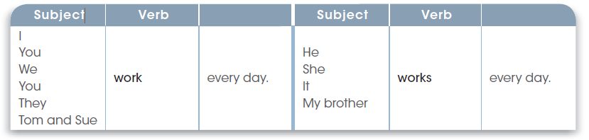

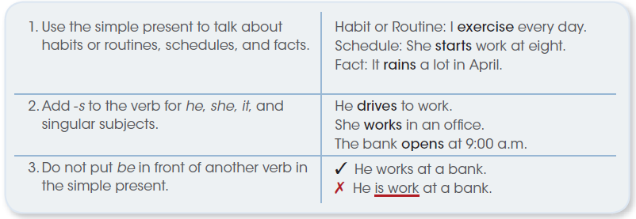

**Circle the correct form of the verb to complete each sentence.**

1. Doctor Moffett love / loves his job.

2. He study / studies ants.

3. A salesperson sell / sells products for a company.

4. You and Anita work / works on weekends.

5. Nurses help / helps people.

6. We write / writes science books.

7. Our office close / closes at 7:00 p.m.

8. She take / takes classes at the business school.

9. You walk / walks to work every day.

10. I start / starts work at 8:00 a.m. every morning.

**Complete each sentence with the correct form of the verb in parentheses.**

1. A zookeeper feeds (feed) animals.

2. Computer programmers (write) software.

3. Photographers (take) photos.

4. A chef (cook) food.

5. A firefighter (fight) fires.

6. Musicians (play) instruments.

7. A farmer (work) on a farm.

8. A dancer (dance).

**Simple Present Spelling Rules: -*s* and -*es* Endings**

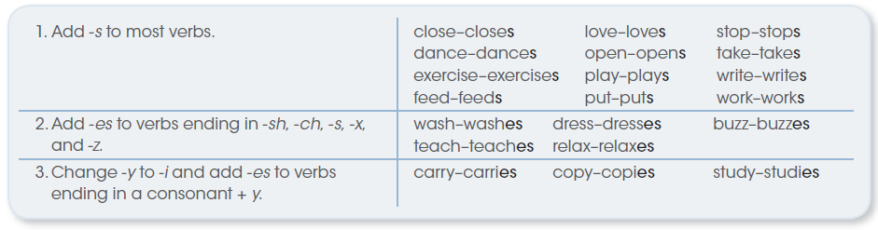

Write each verb with the correct -*s*, -*es*, or -*ies* ending.

1. study 🡺 studies 8. help

2. fish 9. miss

3. pass 10. fly

4. worry 11. fix

5. explore 12. watch

6. bite 13. like

7. buy 14. pay