İKİ FAKTÖRLÜ ANOVA

İki faktörlü ANOVA için yapılması gereken işlemler

- Analyze > General linear model > Univariate
- Bağımlı değişkeninizi Dependent variable kutusuna taşıyın.
- Bağımsız değişkenlerinizi Fixed factors kutusuna taşıyın.
- Options butonuna basin.
- Descriptive statistics, Estimates of effect size ve homogeneity tests üzerine tıklayın.
- Plots butonuna basin.
- Yatay eksene en fazla gruba sahip olan bağımsız değişkeninizi yerleştirin.
- Separate lines’a diğer bağımsız değişkeninizi yerleştirin.
- Add üzerine tıklayın.
- Continue > OK

Çıktıların yorumlanması

- Descriptive tablosu 3 grup için ayrı ayrı örneklem büyüklüğü, ortalama ve standart sapma değerlerini gösterir.

Descriptive Statistics
Dependent Variable: Satisfaction with your life
Religious person | Sex | Mean | Std. Deviation | N
A religious person | Male | 6.89 | 2.313 | 24351
 | Female | 6.91 | 2.316 | 29483
 | Total | 6.90 | 2.314 | 53834
Not a religious person | Male | 6.81 | 2.149 | 11915
 | Female | 6.92 | 2.112 | 10527
 | Total | 6.86 | 2.132 | 22442
An atheist | Male | 6.80 | 2.133 | 2768
 | Female | 6.93 | 1.974 | 1951
 | Total | 6.85 | 2.069 | 4719
Total | Male | 6.86 | 2.252 | 39034
 | Female | 6.91 | 2.251 | 41961
 | Total | 6.89 | 2.252 | 80995

- Tests of between subjects effect tablosundaki p değerleri (sig.) .05’ten küçükse, gruplar arasında istatistiksel olarak anlamlı bir fark olduğunu gösterir. Değilse, gruplar arasında anlamlı bir fark olmadığı söylenecektir. Değişkenlerin birlikte olduğu satırda iki faktörün etkileşimsel etkisi test edilir.

Tests of Between-Subjects Effects
Dependent Variable: Satisfaction with your life
Source | Type III Sum of Squares | df | Mean Square | F | Sig.
Corrected Model | 125.823ª | 5 | 25.165 | 4.965 | .000
Intercept | 1509497.986 | 1 | 1509497.986 | 297831.259 | .000
V147 | 25.137 | 2 | 12.568 | 2.480 | .084
V240 | 58.699 | 1 | 58.699 | 11.582 | .001
V147 * V240 | 44.906 | 2 | 22.453 | 4.430 | .012
Error | 410476.498 | 80989 | 5.068
Total | 4253393.000 | 80995
Corrected Total | 410602.321 | 80994
a. R Squared = .000 (Adjusted R Squared = .000)

- Değişkenlerin etkileşimsel etkisini aşağıdaki grafik yardımıyla yorumlayabilirsiniz. Bu grafik gruplar arasındaki farklılıkların nerelerde artıp nerelerde azaldığını göstererek etkileşimin etkisini görselleştirir.
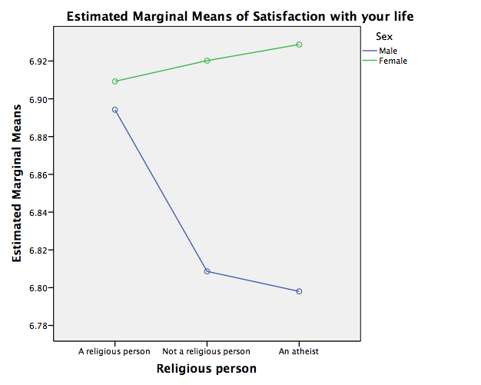
İKİ FAKTÖRLÜ ANOVA – 2

Descriptive Statistics
Dependent Variable: Age
Religious person | Sex | Mean | Std. Deviation | N
A religious person | Male | 41.18 | 16.662 | 24428
 | Female | 42.63 | 16.772 | 29600
 | Total | 41.98 | 16.738 | 54028
Not a religious person | Male | 41.50 | 16.489 | 11964
 | Female | 41.41 | 16.127 | 10604
 | Total | 41.45 | 16.320 | 22568
An atheist | Male | 42.47 | 17.072 | 2778
 | Female | 42.21 | 16.089 | 1968
 | Total | 42.36 | 16.670 | 4746
Total | Male | 41.37 | 16.642 | 39170
 | Female | 42.30 | 16.589 | 42172
 | Total | 41.85 | 16.621 | 81342

Tests of Between-Subjects Effects
Dependent Variable: Age
Source | Type III Sum of Squares | df | Mean Square | F | Sig.
Corrected Model | 33854.168ª | 5 | 6770.834 | 24.545 | .000
Intercept | 56391677.431 | 1 | 56391677.431 | 204428.148 | .000
V147 | 4666.067 | 2 | 2333.034 | 8.458 | .000
V240 | 1068.042 | 1 | 1068.042 | 3.872 | .089
V147 * V240 | 11101.317 | 2 | 5550.659 | 20.122 | .000
Error | 22436604.386 | 81336 | 275.851
Total | 164962315.000 | 81342
Corrected Total | 22470458.554 | 81341
a. R Squared = .002 (Adjusted R Squared = .001)

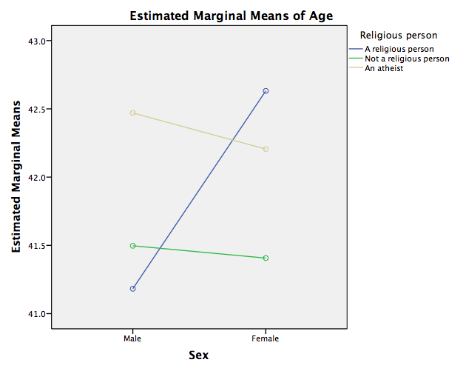

İKİ FAKTÖRLÜ ANOVA – 3

Descriptive Statistics
Dependent Variable: What age did you complete your education
Religious person | Sex | Mean | Std. Deviation | N
A religious person | Male | 20.25 | 10.177 | 21745
 | Female | 20.33 | 11.727 | 26128
 | Total | 20.30 | 11.050 | 47873
Not a religious person | Male | 20.09 | 8.164 | 11143
 | Female | 19.79 | 7.975 | 9874
 | Total | 19.95 | 8.077 | 21017
An atheist | Male | 20.68 | 7.588 | 2574
 | Female | 20.09 | 6.907 | 1805
 | Total | 20.44 | 7.320 | 4379
Total | Male | 20.23 | 9.415 | 35462
 | Female | 20.18 | 10.676 | 37807
 | Total | 20.20 | 10.085 | 73269

Tests of Between-Subjects Effects
Dependent Variable: What age did you complete your education
Source | Type III Sum of Squares | df | Mean Square | F | Sig.
Corrected Model | 2895.518ª | 5 | 579.104 | 5.695 | .000
Intercept | 12068560.229 | 1 | 12068560.229 | 118687.191 | .000
V147 | 1959.020 | 2 | 979.510 | 9.633 | .000
V240 | 535.990 | 1 | 535.990 | 5.271 | .022
V147 * V240 | 804.498 | 2 | 402.249 | 3.956 | .019
Error | 7449657.558 | 73263 | 101.684
Total | 37361870.250 | 73269
Corrected Total | 7452553.075 | 73268
a. R Squared = .000 (Adjusted R Squared = .000)

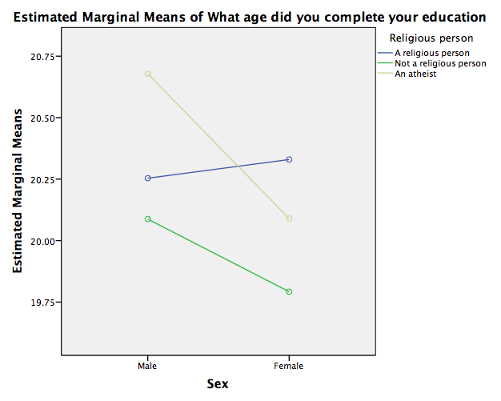

İKİ FAKTÖRLÜ ANOVA – 4

Descriptive Statistics
Dependent Variable: Self positioning in political scale
Religious person | Sex | Mean | Std. Deviation | N
A religious person | Male | 5.98 | 2.358 | 19369
 | Female | 5.87 | 2.305 | 22016
 | Total | 5.92 | 2.331 | 41385
Not a religious person | Male | 5.50 | 2.196 | 9212
 | Female | 5.45 | 2.166 | 7597
 | Total | 5.48 | 2.182 | 16809
An atheist | Male | 4.94 | 2.250 | 2188
 | Female | 4.94 | 2.099 | 1419
 | Total | 4.94 | 2.192 | 3607
Total | Male | 5.77 | 2.324 | 30769
 | Female | 5.72 | 2.276 | 31032
 | Total | 5.75 | 2.300 | 61801

Tests of Between-Subjects Effects
Dependent Variable: Self positioning in political scale
Source | Type III Sum of Squares | df | Mean Square | F | Sig.
Corrected Model | 5002.335ª | 5 | 1000.467 | 191.990 | .000
Intercept | 712699.651 | 1 | 712699.651 | 136766.981 | .000
V147 | 4815.589 | 2 | 2407.794 | 462.055 | .000
V240 | 19.887 | 1 | 19.887 | 3.816 | .081
V147 * V240 | 16.841 | 2 | 8.421 | 1.616 | .199
Error | 322016.869 | 61795 | 5.211
Total | 2366984.000 | 61801
Corrected Total | 327019.204 | 61800
a. R Squared = .015 (Adjusted R Squared = .015)

