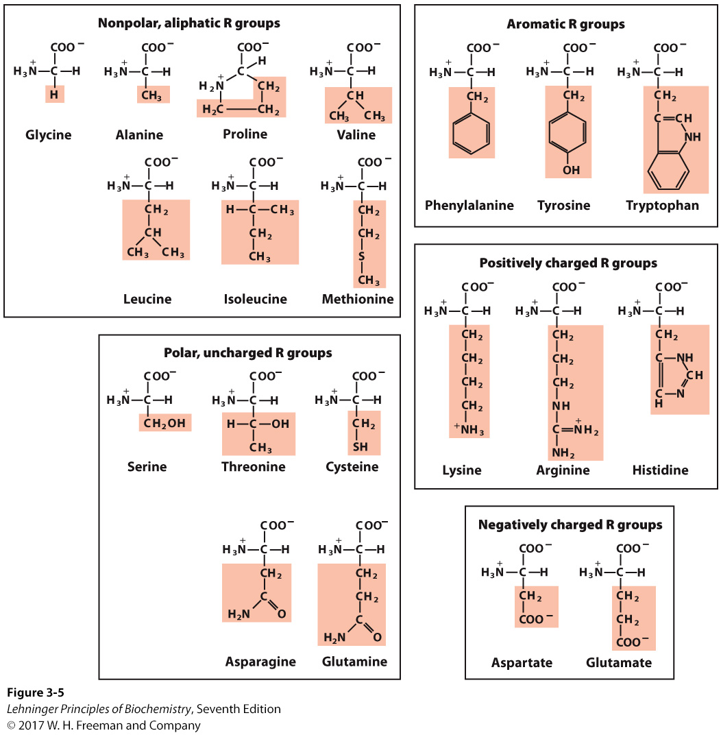
The 20 common amino acids of proteins: The structural formulas show the state of ionization that would predominate at pH 7.0. The unshaded portions are those common to all the amino acids; the portions shaded in pink are the R groups.

Vitamin C and collagen. Why should you eat fresh fruits and vegetables?
Scurvy is caused by lack of vitamin C, or ascorbic acid (ascorbate). Vitamin C is required for, among other things, the hydroxylation of proline and lysine in collagen; scurvy is a deficiency disease characterized by general degeneration of connective tissue.
Manifestations of advanced scurvy include numerous small hemorrhages caused by fragile blood vessels, tooth loss, poor wound healing and the reopening of old wounds, bone pain and degeneration, and eventually heart failure. Milder cases of vitamin C deficiency are accompanied by fatigue, irritability, and an increased severity of respiratory tract infections. Most animals make large amounts of vitamin C, converting glucose to ascorbate in four enzymatic steps. However, humans and some other animals—gorillas, guinea pigs, and fruit bats—do not have the enzyme in this pathway and must obtain ascorbate in their diet. Vitamin C is available in a wide range of fruits and vegetables. Until 1800, however, it was often absent in the dried foods and other food supplies stored for winter or for extended travel.
L-Ascorbic acid (vitamin C) is a white, odorless, crystalline powder. It is freely soluble in water and relatively insoluble in organic solvents. In a dry state, away from light, it is stable for a considerable length of time. The appropriate daily intake of this vitamin is still in dispute. The recommended value in the United States is 90 mg for men, 75 mg for women. The United Kingdom recommends 40 mg, Australia 45 mg, and Russia 50–100 mg. Along with citrus fruits and almost all other fresh fruits, good sources of vitamin C include peppers, tomatoes, potatoes, and broccoli. The vitamin C of fruits and vegetables is destroyed by overcooking or prolonged storage.
So why is ascorbate so necessary to good health? Of particular interest to us here is its role in the formation of collagen. The absence of vitamin C, leads to collagen instability and the connective tissue problems seen in scurvy.

