MATERIAL INFORMATION

2.3.1.1.Atomic filler factor

In crystal lattice structures, the ratio of the volume of the unit cell to the filling rate by atoms is important. This is called the atomic filler factor.

ADF = Atomic volume / Unit Lattice volume

Metals generally include surface-centered cubic crystal lattice, volume-centric cubic crystal lattice and tight hexagonal crystal lattice types.

In the surface-centered cubic crystal lattice, there are atoms in the corners and in the center of the surfaces. The number of atoms in the volume of the unit cage is determined as follows.

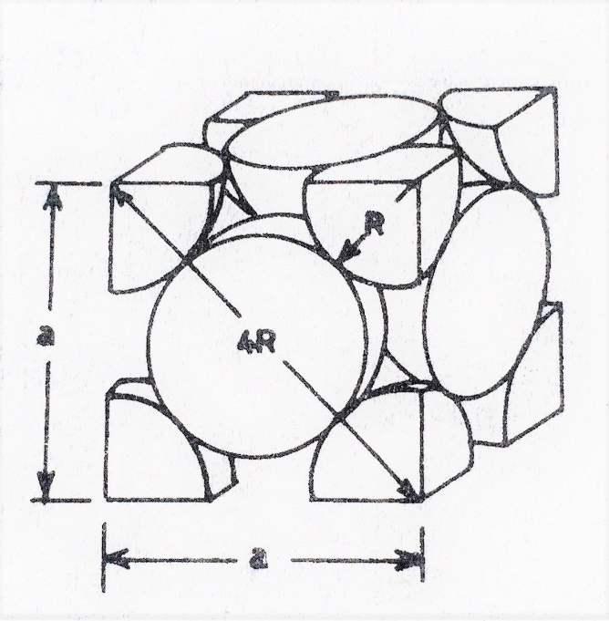

In the corners;

8 x 1/8 = 1 atom

On surfaces;

6 x 1/2 = 3 atoms

The total number of atoms is 1 + 3 = 4.

Atomic filler factor (ADF) for surface-centered cubic crystal lattice; If the margin of the unit cell (a) is taken as the radius (r) of an atom, and from the relationship between a and r a = 4r / (2) ^{1/2;}

ADF = (4 (4/3. π.r³) / a³).100

ADF = 4 (4/3. π.r³ ) / ( 4.r / (2) ^{1/2} ) ³ .100 = 74%

is calculated as. This means that 74%of the unit volume is full and 26% is empty.

As an example of metals of surface-centered cubic structure; γ –Fe, Ni, Cu and Au can be given.

In the volume-centered cubic crystal lattice, atoms are located in the corners and in the center of the cage. The number of atoms in the unit lattice volume
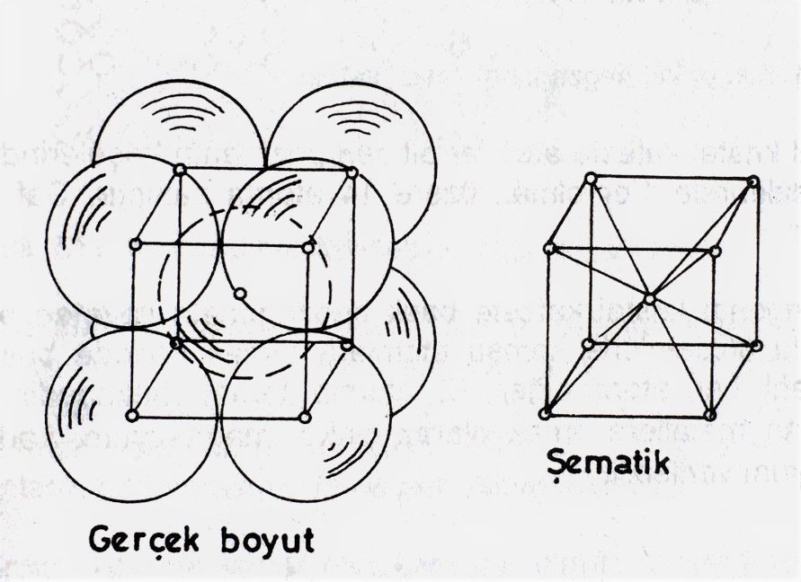

In the corners;

8 x 1/8 = 1 atom

In the center;

1 atom

The total number of atoms is 1 + 1 = 2.

Atomic filler factor (ADF) for volume-centered cubic crystal lattice; If the margin of the unit cell (a) is taken as the radius (r) of an atom, and from the relationship between a and r a = 4r / (3) ^{1/2;}

ADF = (2nd (4/3. π.r³) / a³) .100

ADF = 2.4/3. π.r³ ) / ( 4.r / (3) ^{1/2} ) ³ .100 = 68%

is calculated as. This means that 68%of the unit volume is full and 32% is empty.

As an example of metals of volume-centric cubic structure; α –Fe , Cr and V can be given

The tight package hexagonal Kristal is located in the cage structure, atoms in the corners and in the center. The number of atoms in the volume of the unit cage;

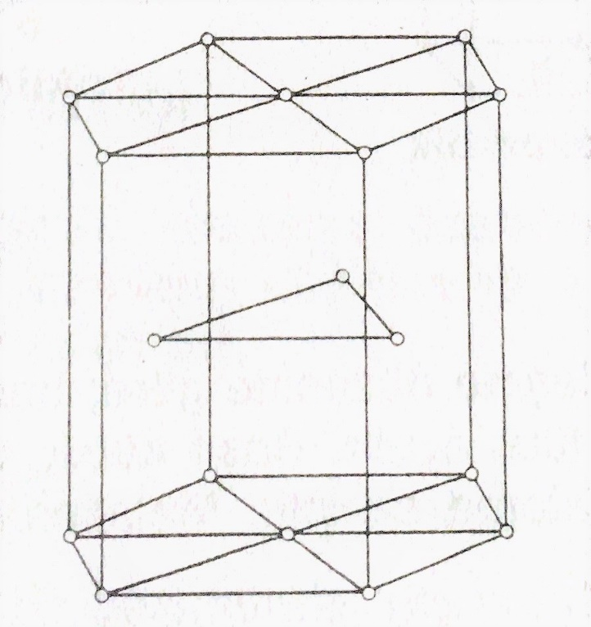

In the corners;

4 x 1/12 + 4 x 1/6 = 1 atom

In the center;

1 atom

The total number of atoms is 1 + 1 = 2.

Atomic filler factor (ADF) for tight package hexagonal crystal lattice; The margin (a) and (c) of the unit cell are taken as theradius (r) of an atom and the relationship between a and r is a = 2r to c = 1,663. a;

ADF = (2nd (4/3. π.r³) / a².c. cos30º).100

ADF = (2nd (4/3. π. (a/2)³) / ( a². 1,633,a.0,866 ) .100 = 74%
is calculated as. This means that 74%of the unit volume is full and 26%isempty.

As an example of metals of volume-centric cubic structure; Mg, Zn and Co.

The crystal structures of ceramic malzemezes are more complex than metals. The ceramic materials used as examples of these structures are given below.

NaCl (table salt)

In the case of naci, each cage has a surface-centered cubic crystal lattice structure with Na and Cl ions.

SiO₂

Widely used in engineering, it has a surface-centered cubic crystal lattice structure similar to the NaCl example.

CaTiO₂

In this structure, there isa rather complex crystal capes structure formed by the intertwining of simple cubic, volume-centered cubic and surface-centered cubic crystals.

Polymer (plastic) materials have a more complex structure than crystal lattice structures seen in metal and ceramic materials. In these materials, molecules in long chains prevent these materials from forming a regular crystal structure. However, by properly regulating the molecular structure in chains, crystallization may occur in half of the structure.

2.3.1.2. Crystal structure errors

Spot errors: Irregularities caused by atoms or atoms in the crystal. These irregularities; The gaps arising from the lack of atoms at normal lattice points are errors such as the entry of foreign atoms into these cavities or the introduction of small atoms into the gaps between atoms. These are in the form of empty space, prime place and entries Figure 2.5).

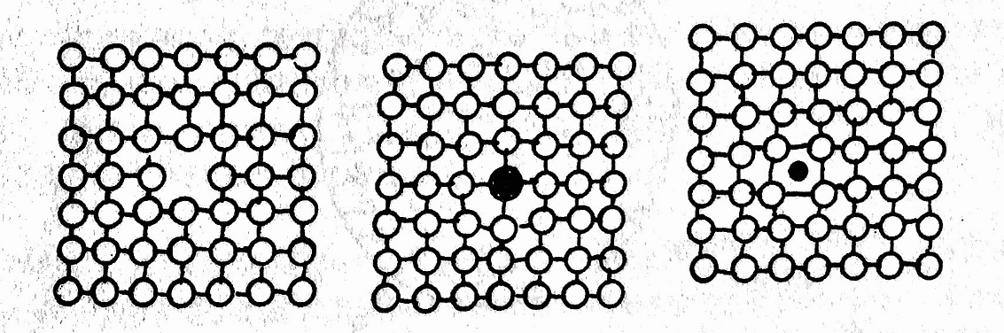

Figure 2.5. Spot errors (vacancy, nobility, intermediate)

Lineic errors – dislocations: Dislocations occur when crystals grow in melt. These are divided into 2 types. Edge dyslocation occurs when an excess atomic plane enters as a result of incompatibility between the two parts during crystal formation. Screw dislocation occurs as a result of the displacement of an atom sequence within the crystal structure by sliding in the direction of the axis to the distance between atoms Figure 2.6).

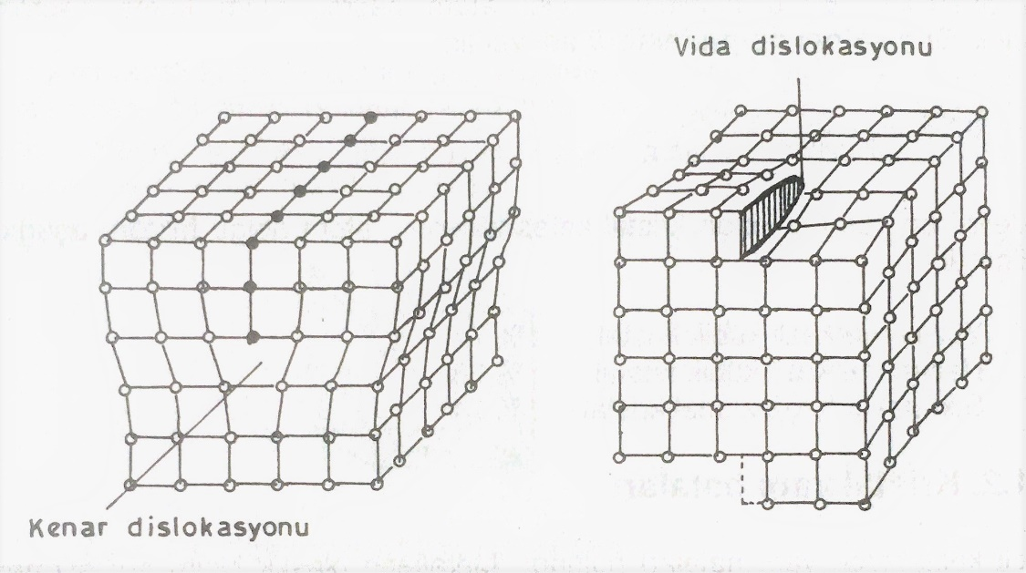
Figure 2.6. Lineal errors

Superficial errors: During solidification, a large number of crystalline grains are formed, depending on the number of crystal cores, the structures are the same but the positions are different. Atoms between crystalline particles cannot adapt to neighboring particles Figure 2.7).

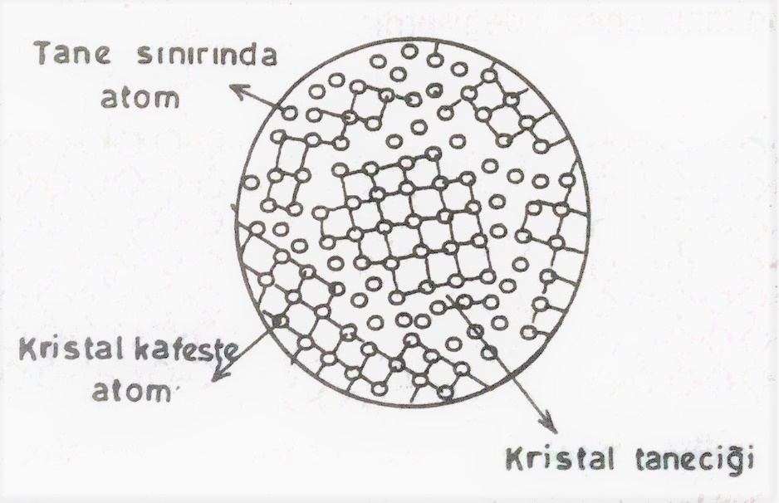

Figure 2.7. Superficial errors

2.3.2.Molecular structure

Groups that have a certain number of atoms connected to each other by valans or ion bonds are called molecules. Small molecules are called monmers. Polymer is obtained by connecting a large number of monomers under certain conditions. These are materials called plastics in practice.

2.3.3.Amorphous structure

This structure occurs in materials that do not have a specific pattern of repeated atoms, that is, they have irregular sequences. Atoms are similar in all gases and liquids, plastic materials and extremely fast cooled metals.

The glass solidifies, maintaining its irregular structure in liquid form. Therefore, it takes the name of overcoated liquid. If molted metal is poured into a thin layer on a surface at a very low temperature, an amorphous structure called glass metal is formed.

2.4.Publication – Diffusion

The displacement of atoms, ions and other particles due to heat is called broadcasting.

The publishing event is used in the production and heat treatment stages of metals in the industry. For example, the principle of non-publication is used in welding, semantics, and galvanizing operations.

