MATERIAL INFORMATION

3. INTERNAL STRUCTURE FORMATION OF MATERIALS

In materials, homogeneous regions with the same structure and characteristics within certain limits are called phases. The groups of atoms found in these regions are regularly arranged and balanced.

3.1.Phase Transformation

If the equilibrium conditions that make up a phase change, the atoms move to a new equilibrium position. Thus, the transition from one balance structure to another balance structure is called phase transformation.

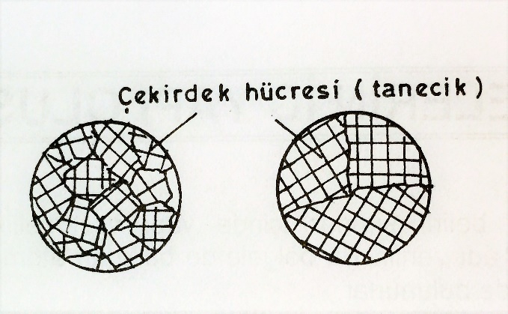
Figure 3.1. Thin and thick granuth structure

The materials are in a balanced position under the influence of interatomic bond forces. When the balanced position is disturbed for any reason, the atoms move to another balanced position, that is, a new phase position. The phase can be more than one state of any substance, not only solid, liquid or gaseary, but even when it is solid. In general, the phase is defined as homogeneous regions with the same structures and characteristics within certain boundaries.

Energy is the most important factor in phase formation and transformation. The most important factors affecting this are temperature, pressure and composition ratio. Balance diagrams containing phase and phase changes provide important information on this subject according to temperature and composition ratio.

The heat energy given to ensure phase conversion in materials (e.g.transition from solid phase to liquid phase) gives the atoms vibration motion. When a certain temperature value is reached, the vibration movement defeats the interatomic bond force, causing the atoms to be released. This creates the beginning of the liquid phase. The temperature does not rise until the liquid phase is completed. The reason the temperature remains constant is that the given heat energy is used in internal energy. This situation is reversible. In other words, it is also valid when switching from liquid phase to solid phase. At the beginning of solidification, the vibration movement of atoms decreases. Although the cooling continues, the temperature remains constant. The fact that the temperature remains constant is the release of the heat energy used in the internal energy in the previous event.

The number of crystal groups formed when metal materials solidify, cooling rate and number of cores are effective. Each group of crystals is called grain. The higher the cooling rate, the greater the number of particles (Figure 3.1)

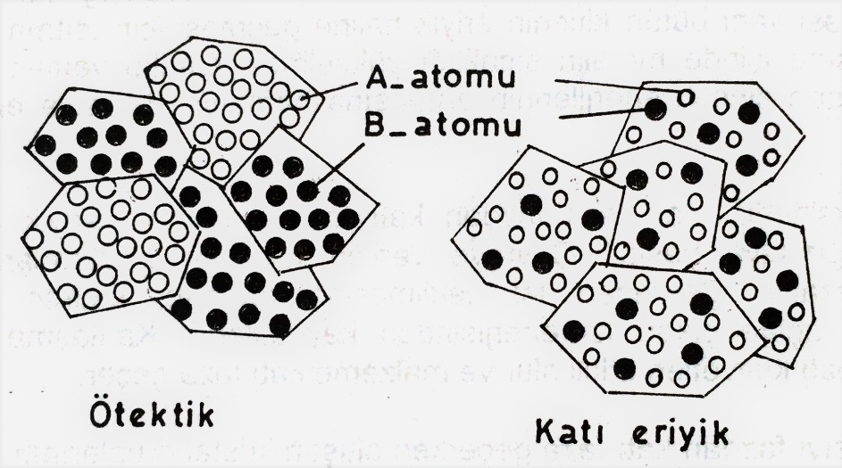

Figure 3.2. Appearance of euthic and solid melt phases within the tissue

3.2.Metal Alloys

The properties and uses of pure metals used in engineering applications are limited. Alloys have been obtained to expand the properties and uses of metals.

The basic substances that make up the alloy are called components. Alloys are obtained by melting the components together. At least one of the elements that make up an alloy must be metal. Another important rule for alloying is that when in melt form, the components must dissolve completely in each other. The internal structure of the alloy obtained by cooling the melt is divided into two types, solid melt and euthanasia (Figure 3.2)

3.2.1. Solid melts

In solid cases, they are obtained from components that dissolve in each other, that is, form a common cage. Solid melts have a single-phase structure. The component with an excess amount is called the dissolving one. There are two kinds of solid melts; the place and the place. If some of the dissolving lattice points are filled by the atoms of the dissolved component, the solid melt is called the intermediate solid melt if the dissolved component is located in the space between the atoms of the component that dissolves the atoms Figure 3.3).

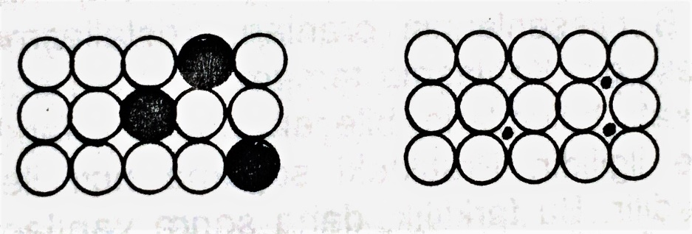
Figure 3.3. Ground and intermediate solid melt

The sizes of the atoms of dissolved and dissolved components in the solid melt type and the types of crystal lattices are similar (for example, Copper and Nickel alloys). In the intermediate solid melt, the diameter of the dissolved component atoms is quite small relative to the soluble (in carbon, hydrogen, nitrogen atoms). For full resolution to occur, components must meet hume – rothery requirements. These conditions are given below.

- The difference between the radiuses of component atoms should not be greater than 15%.
- Components must be of the same crystal mesh structure.
- Components must have the same number of waltz electrons.
- Components must be of the same electro-negativeness (ability to draw electrons)

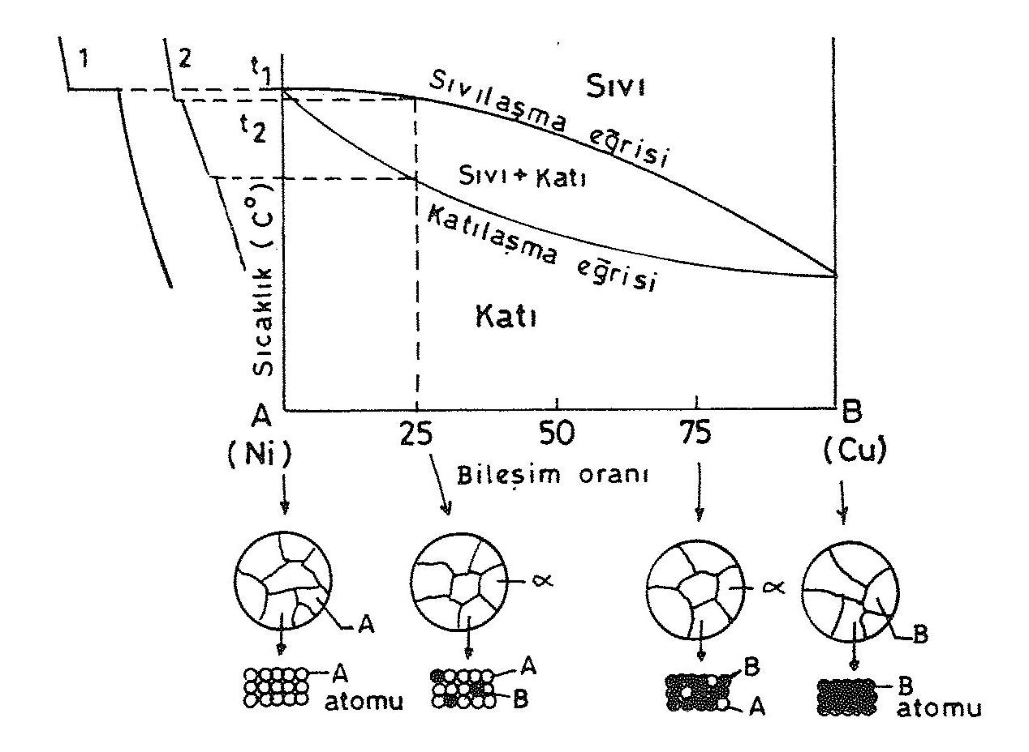

Figure 3.4. Solid melt balance diagram

Alloys that form solid melt contain two bend points in cooling curves.

In the balance diagrams of the alloys that make up solid melt, solid and liquid are co-located in closed areas in the form of lentils. The curve liquefaction curve, which limits the closed area from the top, is called the curve solidification curve, which limits from the bottom.

Crystallization occurs when the alloy, which is located in a completely liquid form above the liquefaction curve, goes below this curve during cooling. With the ongoing cooling, the rate of crystallization increases. When it goes below the solidification curve, the entire alloy solidifies.

Solid melt alloys have higher strength than their components. For example, in copper – nickel solid melt alloy, in the lattice structure of the copper component, nickel causes the strength of the copper alloy to be higher than pure copper by the introduction of nickel intermediate atoms (Figure 3.4).

The effects of solid melt alloy on the properties of materials can be listed as follows;

- The hardness, tensile and flow strengths of solid melt alloys are larger than the components (pure metals) that make up the alloy.
- The ductivity of solid melt alloys is usually lower than the pure metals that make up the alloy.
- The electrical conductivity of solid melt alloys is lower than its components.

3.2.2.Euthanasia

In these alloy types, no change occurs in the lattice structures of the components that make up the alloy. The components protect their own crystals in the alloy. In such alloys, common characteristics or properties dominated by the property of the component with a high ratio in the alloy, depending on the proportions of the components. Such double-phase alloys are called euthanasia.

There are two phases in this alloy. So the two components form their own crystals. The euthanasia alloy has a single and lowest melting and solidifying temperature, such as pure metals. This is due to the tendency of the two component atoms to prevent the atoms of the other component from forming their own crystals. Therefore, both components begin to form their crystals at the same time. Crystallization is completed in a very short time if strong heat is drawn from the environment. Therefore, crystal particles are obtained in large numbers and fine-grained. Alloys with a euthic ratio therefore have very good mechanical properties.

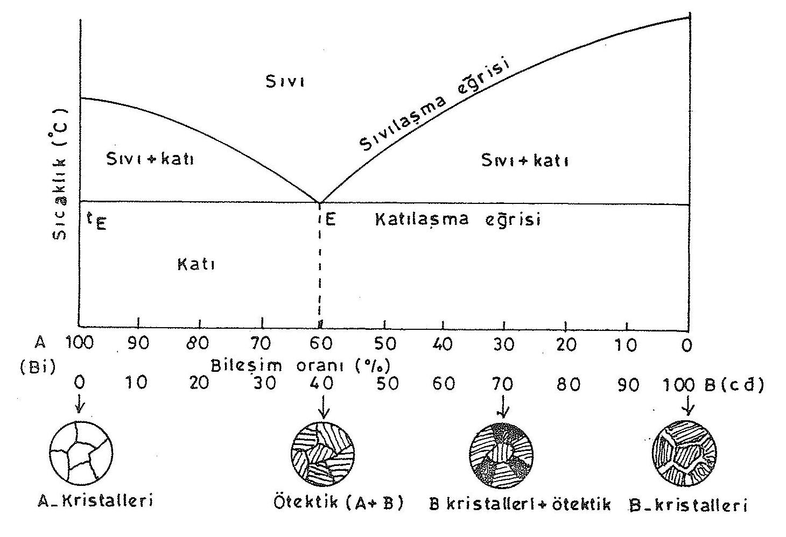

Figure 3.5. Euthanasia diagram

At component ratios other than the euthanasia ratio, the atoms of the component, which is greater than this ratio, form their own pure crystals. This component approaches the euthanasia rate by reducing the rate in melt. When it reaches the euthanasia rate, the remaining melt crystallizes in a structure similar to the euthanasia ratio.

The balance diagram was obtained by using the stop points of the two metals in pure form and the bend points of alloys of different proportions in case of cooling. In the diagram, point E indicates the euthanasia rate, and_{t-E} indicates the euthanasia temperature. In euthanasia alloys, the ratio at which absolute homogeneity is achieved is called euthanasia ratio, and temperature is called euthanasia temperature. The euthanasia temperature value is below the melting temperatures of both alloying components. In the diagram, the euthanasia alloy consists of approximately 40% cadmium and 60% bimut Figure 3.5). The alloy of this proportion has a single curvature and solidifying temperature, like pure metals. At this rate, both components that make up the alloy begin to form their own crystal structures at the same time. Due to the tendency of the component ratios that make up the alloy to prevent crystal lattice creation, the solidification temperature at the euthanasia rate occurs at a low value. Alloys at the euthic rate are suitable for casting because the degree of melting is low and the self-pull rate is low.

At component ratios other than the euthanasia ratio, the atoms of the component, which have a higher ratio than the euthic ratio first, form their own crystal structure. This formation continues until the proportions of components in the melt approach the euthanasia rate. When the component ratios in the melt reach the euthanasia rate, the remaining melt crystallizes in a structure like the euthanasia rate.

