MATERIAL INFORMATION

4.3. Physical Characteristics

Many of the physical features are units of weight, water absorption, permeability, acoustics, which are important for building materials such as ceramic-based stone and brick concrete.

4.3.1. Unit weight

The volume of an object is equal to the sum of the space volume with the full volume.

V = V_{d} + V_{b}

In this equation, V volume, V_{d} full volume, V_{b} gap volume.

The total volume of the cavity volume is called porosity.

P = V_{b} / V

The total volume ratio of the hail volume is called compensation.
k = V_{d} / V

The following equation can be written between the porosity and the compulsion of an object from these relationships.

P + k = 1

The unit weight of an object is calculated by the ratio of the dry weight of the object to the volume.

B = G_{k} / V

4.3.2. Permeability

Under pressure, fluids pass through cavity materials. The most common fluids are water and water vapor. Pressurized water permeability is important for materials used in water tanks and dams.

4.3.3. Water absorption

Some cavity materials in contact with water have water permeability even in non-pressure conditions. It's called water absorption.

4.3.4. Acoustic properties

Sound waves are emitted by atom or molecular movements in appropriate environments. Acoustic properties are related to the transmission, reflection, absorption and insulation of sound.

4.4. Technological Features

They are the characteristics of the elements to be manufactured related to the manufacturing methods.

Spillability: It is the property of the material to be suitable for manufacturing by casting method. When solidified, the spillability of the material, which does not attract much, does not create much space, is fluent in melt form, is good.

Formability: Features related to the suitability of the material to formatting methods such as bending, forging, bending, rolling.

Weldability: The ability of one metal to be connected to itself and another metal by welding.

Machining: It is suitable for drilling, turning, grinding. Short chips, smooth surface

5. METAL MATERIALS

Metals are the most used materials in application with their superior mechanical properties. Since pure metals are soft and low in strength, they are often used by increasing their strength and hardness by methods such as alloying, cold forming and heat treatment. The weaknesses are that they are not very resistant to corrosion.

Metals are divided into two main groups: iron and non-ferrous metals.

5.1. Iron Materials

Iron is obtained as raw iron in a facility called a high furnace. The inputs of the high furnace are iron ore, coke and slag-making limestone.

Raw iron and slag are obtained from the base of the high oven in melted form. Foreign elements such as phosphorus, sulfur and silicon found in iron ore also enter raw iron.

Raw iron obtained from the high furnace are two groups: gray and white.

Gray Iron: Silicon effect prevails. Silicon delays cooling and acts on the formation of carbon in graphite.

White ham Iron: Manganese influence prevails. Manganese acts on the compounding of carbon in the form of iron carbide together with iron.

The first area where raw iron is used is melted and the necessary additives are added and poured into molds. It's called cast iron.

The second area where raw iron is used is the acquisition of steel. Carbon in raw iron is reduced to 2%.

5.1.1. Polymorphy of iron (allotropia)

The pauses that indicate the change in structure and properties occurring outside the melting and solidification points in metals are called polymorphs.

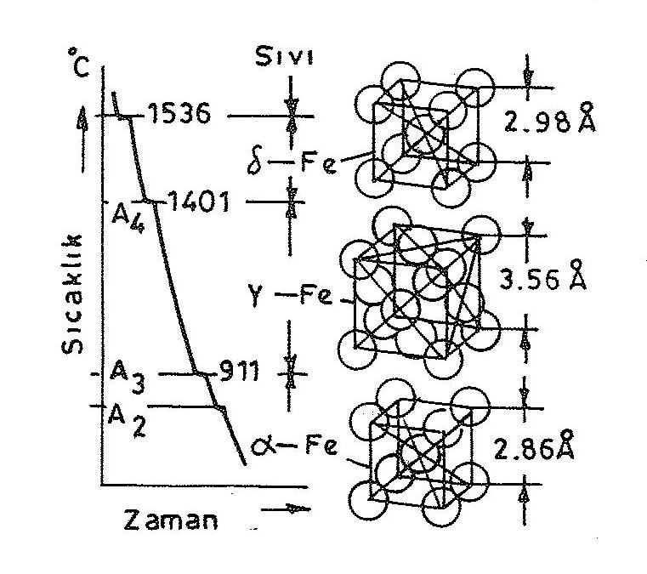
Figure 5.1. Cooling curve and allotropia of iron

It is seen that there are three polymorphs in the cooling diagram of pure iron. 1536 ºC also consists of volume centered cubic crystal lattice. If cooling is maintained, there is a second stop point at 1401 ºC. Here it becomes the surface-centered cubic crystal lattice structure of the structure. 911ºC consists of cubic crystal lattice centered on volume again at the stop pointat C. The fourth stop point is 768 ºC, where the crystal structure does not change, but the feature changes. At this point, magnetic properties occur (Figure 5.1).

