MATERIAL INFORMATION

5.1.2. Iron – carbon balance diagram

Crystal structure transformations occur again when iron is alloyed. But these transformations occur at different temperatures. For example, carbon, the element of iron alloy, lowers the melting temperature of pure iron.

Ferrite

At ahigh furnace temperature of approximately 1600 ºC, iron is liquid, and carbon is mixed into the melt. In the case of slow cooling, carbon atoms come together to form in graphite. The element silicon helps to form the internal structure in the form of ferrite + graphite. As the temperature drops, so does the ability of iron to dissolve carbon. While iron in the gamma crystal structure dissolves a certain amount of carbon, iron in the alpha crystal structure does not dissolve carbon. Alpha iron in the cubic crystal lattice structure centered on carbon-insoluble volume is called pure iron, that is, ferrite.

Cementitis

Cementitis is an orthoscopic crystal lattice material containing 93.33% ferrite and 6.67% carbon. When iron containing carbon element is cooled quickly, carbon does not have time to crystallize, resulting in iron carbide (Fe₃C) alloy. In this formation, the element manganese facilitates the formation of this structure. Cementitis is hard and brittle.

Austenitis (Ostenite )

Since iron is the main component in iron and carbon alloys, carbon atoms dissolve within the crystal lattice structure of iron. When the liquefaction curve is below, mixture crystals begin to form in the liquid in the alloy, which contains up to 1.7% carbon in its structure.

While the first crystals formed were low carbon ratio, in the crystals formed towards the end, the carbon ratio is high. The 14-atom surface-centered cubic crystal structure that occurs when solidification ends is called ostenite. Ostenite is solid melt structure. It can dissolve up to 1.7% carbon at 1147 ºC. Ostenite also reduces the carbon content it can dissolve as the temperature drops. The carbon ratio ^{that it}can dissolve at 723 ºC is 0.85%.

Perlite

Ostenite consisting of 14-atom gamma crystals turns into alpha crystals with 9 atoms at 723 ºC. This transformation completes the crystal structure with a carbon ratio of 0.85. Thus, the ostenite structure creates a euthanasia by reaching its ideal structure with a carbon ratio of 723 ºC and 0.85. However, the resulting euthanasia is perlite, which is euthetite, not euthetical, as it occurs in solid melt.

Perlite has a bright and fingerprint-shaped structure. Because of this bright image, it is also called perlite, which means pearl in English. In the balance diagram, this euthothyte structure is located in the steel’s region. Therefore, this region, which forms steel varieties, is called sub-euthoite and perlite steels.

Ledeburit

In the balance diagram, the structure above the V-shaped liquefaction curve is liquid. The structure below the line at the bottom of this curve is solid. Between this curve and the line is the hardening or melting zone of the alloys. Pure components, or alloys of a certain proportion, indicate a single solidification point in this region. Iron – When the carbon ratio in the carbon alloy is 4.3%, the alloy is called euthanized alloy ledeburit at 1147 ºC, which is the lowest solidification (melting) temperature.

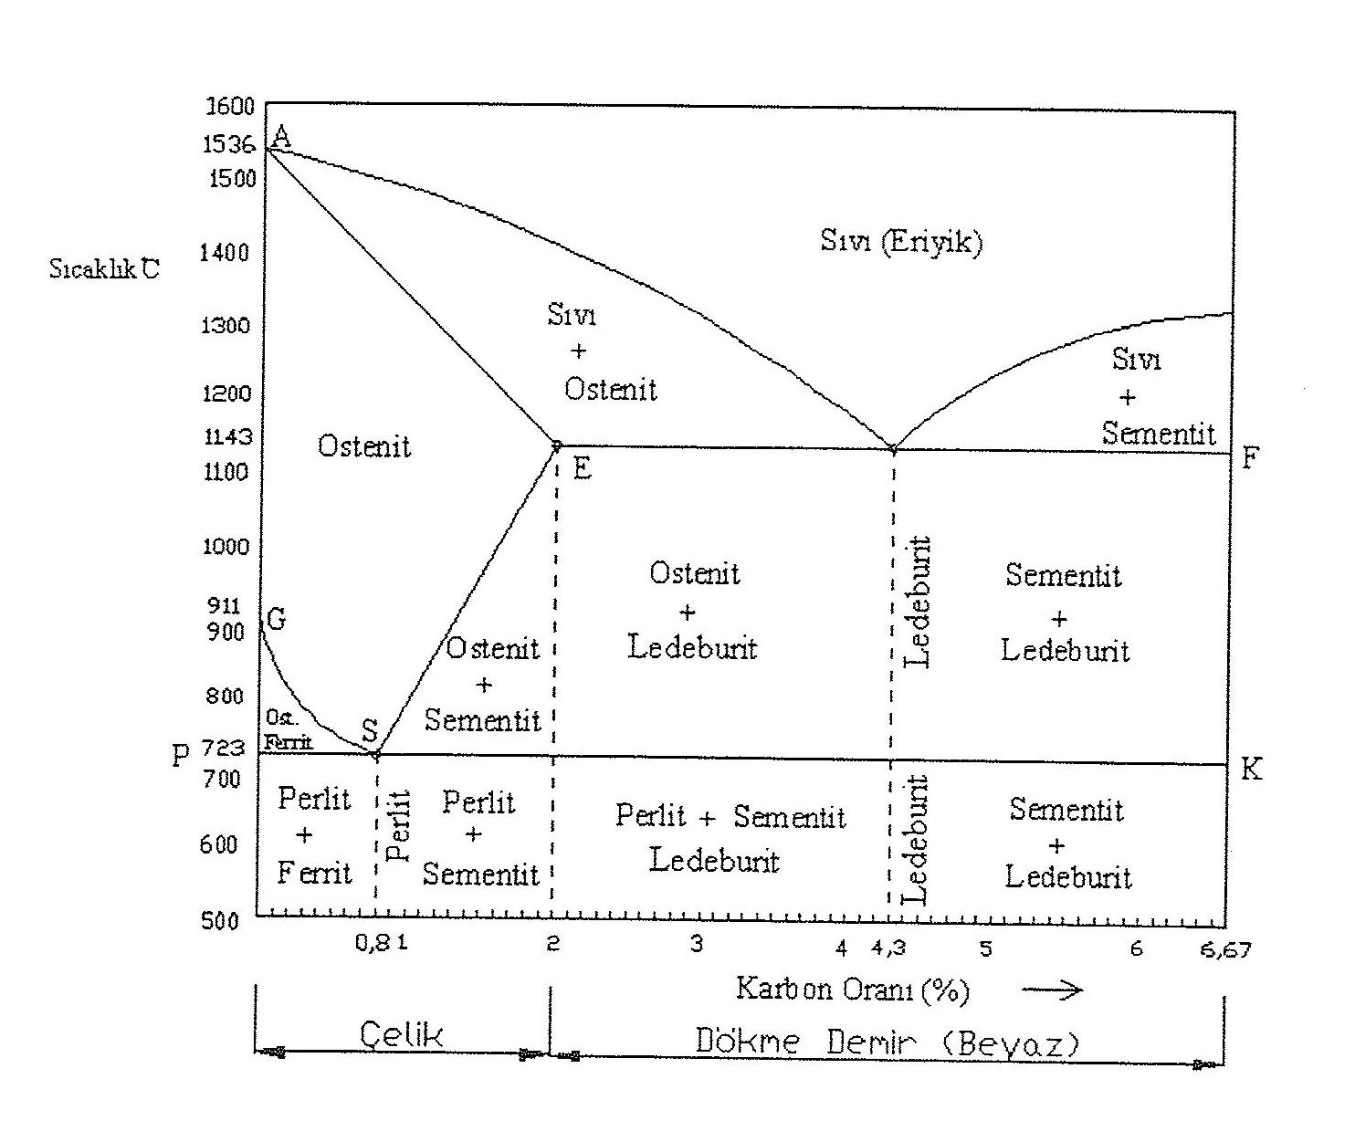

Figure 5.2. Iron-Carbon (cementite) balance diagram

The iron-carbon equilibrium diagram includes pure iron (ferrite) at the left and cementite components at the right end. The region where the carbon ratio range is 0-2% is steel, and the region where it is 2-6.67% is called the cast iron zone (Figure 5.2).

In the steel region, which is the first region, crystals begin to form when the liquefaction curve is reduced during the cooling process. These structures consisting of surface-centered cubic iron crystals with carbon atoms at their center are called alpha solid melt or ostenite. The ability of these structures to dissolve carbon decreases as the temperature drops. If the temperature in one place is reduced to 723 ºC and the carbon content is 0.85%, the structure becomes completely perlite.

If the carbon ratio in ostenite is in the range of 0 – 0.85%, when it falls below the GS curve in the balance diagram, ferrite (alpha) crystals with a higher ratio than euctite ratio are precipitated. The remaining ostenitis turns into perlite in 723 ºC. Ferriteand perlite are found together in the area below 723 ºC.

If the carbon content in ostenite is in the range of 0.85-2%, more than 723 oC of carbon is precipitated as cementite. At 723 ºC and at a carbon ratioof 0.85%, the remaining mixture crystals turn into perlite. Thus, the structure consisting of cementite and perlite at room temperature is hard and crunchy.

In the balance diagram, the region with a carbon ratio of 2 – 6.67% is the cast iron zone. In the formation of this structure, the ratio of silicon is effective together with the carbon ratio and cooling rate. In case the silicon ratio is more than 1%, white cast iron is obtained provided that the cooling rate is high, and gray cast iron is obtained if the cooling rate is slow.

