MATERIAL INFORMATION

7. CERAMIC MATERIALS

In ceramic application, it is the general name given to materials such as stone, brick, tile, concrete, glass, enama, porcelain. Ceramics are obtained by cooking soil-based clay, kaolen, etc. at high temperatures.

7.1. General Properties of Ceramics

Ceramics are usually very hard and crunchy – fragile materials. Their strength is high against pressure and very low against pull. Tensile strengths can be increased by heat treatments.

7.2. Interior Structures of Ceramics

Ceramic excesses are mostly crystalline and some are amorphous because they do not crystallize. The formation of atoms in ceramic crystals is complex. Since the bonds are also strong, phase conversion speeds are slow. Therefore, the cooling rate has a large effect on the formation of internal structure. An example is the solidification of glass during its normal speed, maintaining its liquid amorphous structure.

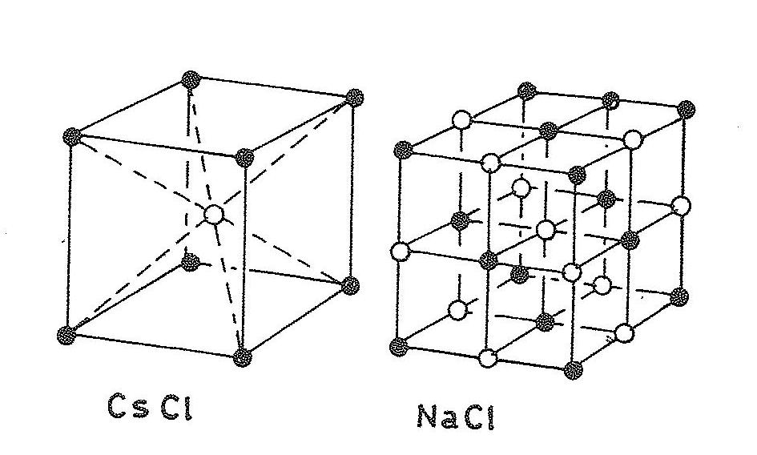

Figure 7.1. AX type ceramic crystals

7.2.1. Crystal structures

Crystals with equal two elements are the simplest ceramic compounds. There are an equal number of metal and non-metal elements. There is a certain ratio of dimensions between atoms (Figure 7.1)

The ratio of two elemental crystals with unequal numbers is 1/2 or 2/3.

Three-element crystals have a more complex structure than two-element compounds (Figure 7.2).

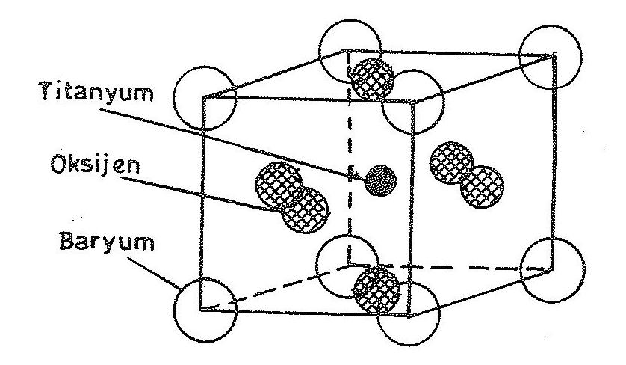

Figure 7.2. Barium titan oxide crystal

7.2.2. Silicates

The most important component of this group is silicate. The majority of ceramics contain various types of silicates. They are abundant in nature. Therefore, the cornerstone of building materials such as concrete, brick, tile, glass and porcelain are silicates. As in Figure 7.3, space network structures formed by the silica of the adjacent unit silicates of oxygen atoms form an amorphous silica if they are arranged irregularly.

