MATERIAL INFORMATION

7.3. Ceramic Types

The types of ceramics widely used in the industry are glass and terracotta products.

7.3.1. Glasses

They are solidified materials that do not have a certain atomic order, that is, maintain the amorphous structure in melted form. They are very hard and fragile, and their most important feature is that they are transparent.

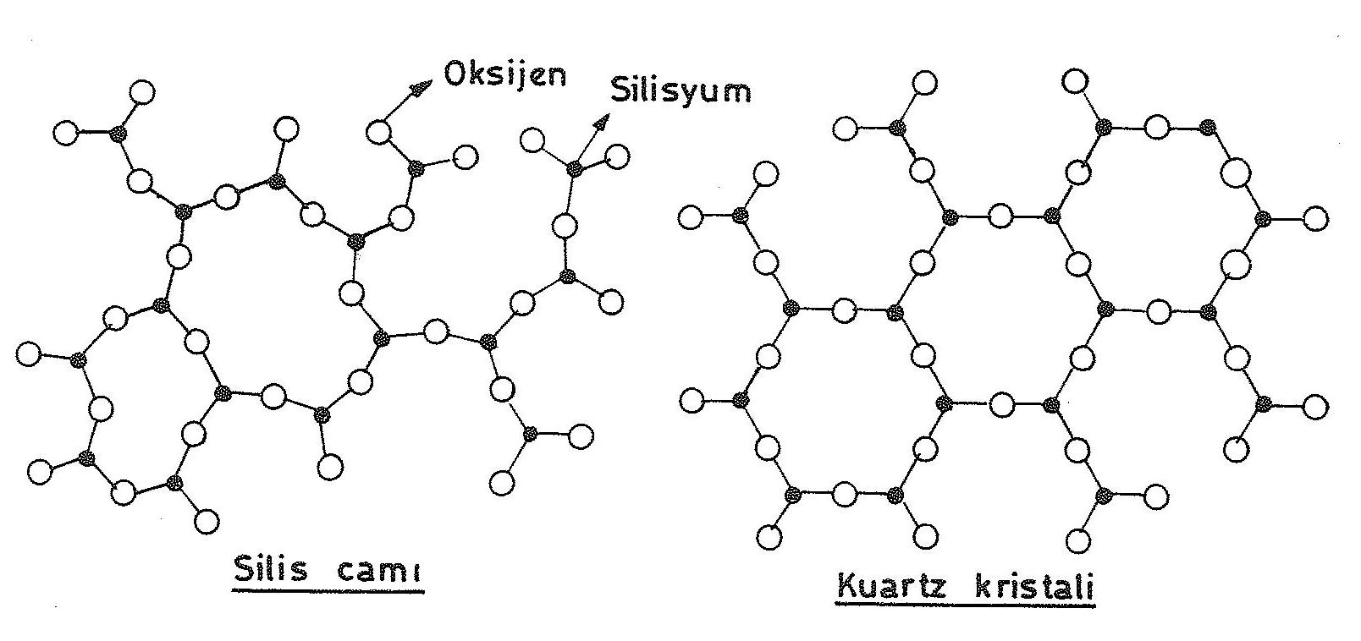

Figure 7.3. Silicate structures

Glass is inorganic-based silicate with high viscosity even at high temperature values, solidifying without crystallization in normal cooling. The gradual plus in its viscosity in the process of cooling the glass provides a wider working temperature than its metals. The main component of the glass is siliconoxytocin (SiO_{2),} which is located in the amorphous structure, which provides transparency. Glass is very hard and brittle, high compression resistance, resistant to chemical effects of air, water and acids (other than Flour acid).

It can be processed with materials such as diamonds and sintered chloride at room temperature. It is also used in the production of glass fibers.

Glass production consists of the preparation of the main substances, melting, forming, cooling and annealing stages. As already mentioned, the main component of the glass is silicon oxide. In addition, the added metal oxides give the glass different properties. Magnesium oxide (MgO) facilitates mechanical properties in glass. Crystal barium oxide (BaO) and lead oxides (PbO, Pb₃O₄₎ are used to increase thedensity of glass and the ability to break light, while aluminum oxide is used to resist pressure and heat. In addition, various substances are used to give different properties such as coloring to glass.

After the aforementioned purpose-built mixtures are created, these mixtures are heated in rotary ovens or pots up to approximately 1500 ºC. As the temperature increases, fluidity increases, and transparency occurs. The glass forming temperature ranges from 1000 to1200 ºC. Various forming methods are applied according to the material to be produced. Previously, methods in the form of blowing, pulling and molding have been replaced by mechanical and automatic industrial methods today. Cracking occurs if the glass removed from the oven is left to cool at normal temperature. To prevent this, slow cooling is carried out. Annealing is performed to relieve internal stresses that may occur during cooling.

Silica glass (siO₂₎ is a compound with very good properties in glass creation. It is used in the construction of temperature-resistant glass products.

Soda – lime glass silica is obtained by adding soda (Na₂O) and lime (CO). Window glass is used in the construction of cheap glass. Na₂O and CaO facilitate the shaping of glass. This glass is resistant to chemical effects and water and has a high hardness.

Leaded glass silica is obtained by adding lead oxide (PbO). It is used in the construction of precious glass called crystals. Glass with high levels of lead oxide has a low melting temperature and has high reflective and dispersive properties. They are located in optical systems, since their electrical and radiation crushing properties are better than normal glass.
Boron silicate glass is obtained by adding boron oxide (B₂O₃₎ tosilicate. It is resistant to chemical effects and high temperature. It is used in the production of laboratory tools and fire-resistant glassware. Pyrex de boron is silicate glass.

These glasses containing approximately 20% Al2O₃are resistant to high temperatures. Laboratory tools, fire resistant glassware, kitchen utensils and projectors are used.

Safety windows are a special type of glass that is very hard to break and does not form cutting parts when broken. These glasses are obtained using different methods. In the most commonly used method, this type of glass obtained by placing a transparent plastic plate (polyvinylbutiral foil) between two glass plates is called triplex.

In another method, a fence is placed between two glass plates. Thus, its resistance to breakage is increased and its disintegration is prevented when it is broken.

Glass fiber is pushed through holes at the base of a crucible made of melted glass, platinum or platinum alloy to a certain pressure and flow. With the rapid withdrawal of glass from the holes, it rapidly grows and shrinks in diameter into fiber. Then polymer is sprayed on the glass that is turned into fiber, increasing its resistance to corrosion. The fragility of the glass, which is turned into fiber, is also reduced.

7.3.2. Cooked clay products

Clay is one of the components of the soil, obtained from the crumbs of the rocks as a result of any effect. The main component of the lock is silica, alumine and water. Clay also contains oxides and alkalines.

7.3.3. Cement and concrete

It is a ceramic-based composite material consisting of a mixture of concrete cement and sand and gravel. Here is the cement binder-matrix.

