MATERIAL INFORMATION

8. COMPOSITE MATERIALS

They are materials consisting of two or more materials that are put together to achieve better properties by covering each other's weaknesses. In these materials, the components are macroscopic.

8.1. General Properties of Composite Materials

They are produced to obtain one or more of the feature combinations such as strength, density, high temperature resistance, corrosion resistance, hardness and conductivity.

8.2. Internal Structures of Composite Materials

Composite materials are divided into three main groups: granulated, fiber-reinforced and layered. Metal-metal, metal-ceramic, metal-plastic, ceramic-plastic, ceramic-ceramic or plastic-plastic materials can be combined to obtain them.

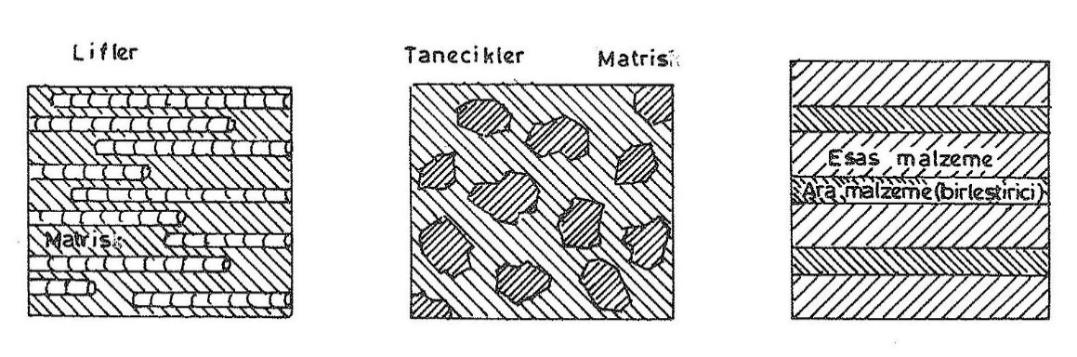
Figure 8.1. Internal structures of composite material groups

6.2.1. Particle – granulated composites

They are materials that hard and crunchy small parts form with a softer and more perched matrix. Examples of these composites include concrete, sinter materials and hard metal tips.

Sinter materials and hard metal tips are composite materials used in the machinery industry. In sinter materials, metal, metal oxide or metal carbide powders are mixed and pressed in mold and cooked. The parts are connected to each other either by atomic diffusion (solid sintering) or by the method by which the binding metal melts and crystallizes by forming this phase between carbide particles (liquid sintering).

8.2.2. Fiber reinforced composites

Soft and perch are materials obtained by placing hard, durable and elastic fiber in the connector-matrix. While fibers carry a large part of the applied load, the matrix ensures that the load is transported to the fibers, as well as creating ductiness and satiety. Examples include adobes used in simple structures, concrete with steel rods, gear pipe reinforced glass wool, purifier drug tank.

8.2.3. Layered – layered composites

They are materials obtained as a result of combining layer-plate material with different properties with a binder.

Low cost, high strength and light weight are at the forefront of these composites. Examples include vehicle front shield windows, formica and plytraplak, where two layers of glass are combined with plastic, and composites with sues and three-layer plow end iron layers.

