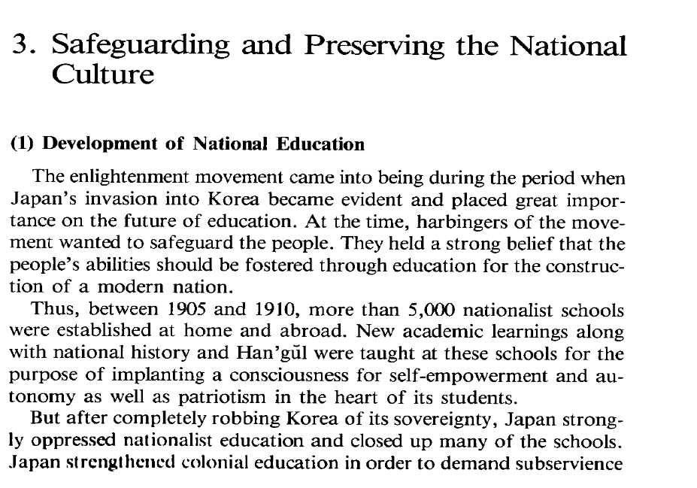
Resim 1 Radio Korea International Korean Broadcasting System. 1995. The History of Korea. Seoul
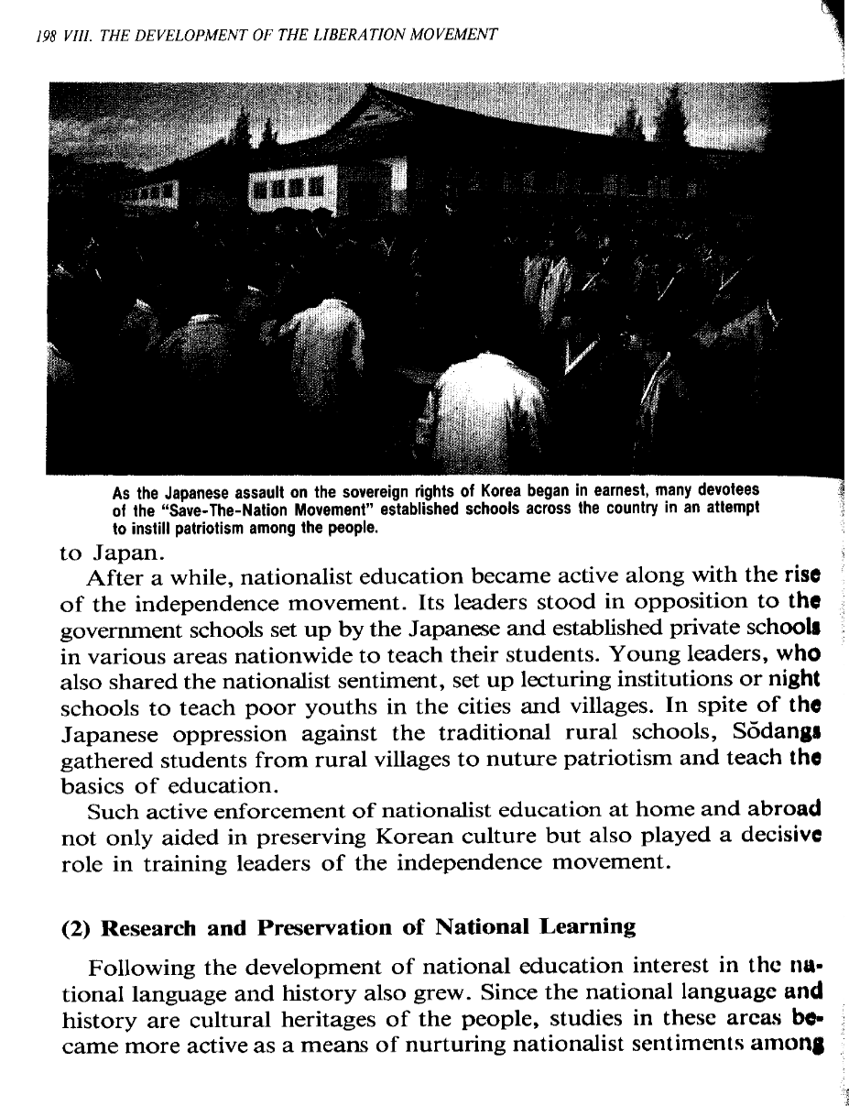
Resim 2 Radio Korea International Korean Broadcasting System. 1995. The History of Korea. Seoul
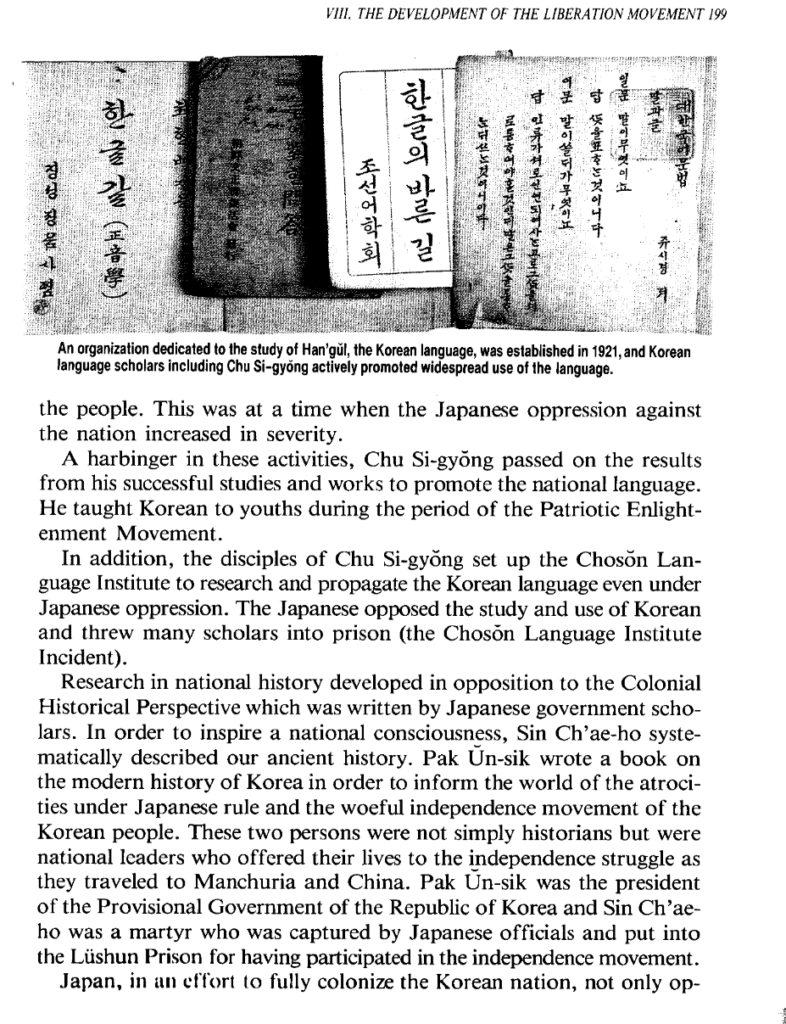
Resim 3 Radio Korea International Korean Broadcasting System. 1995. The History of Korea. Seoul
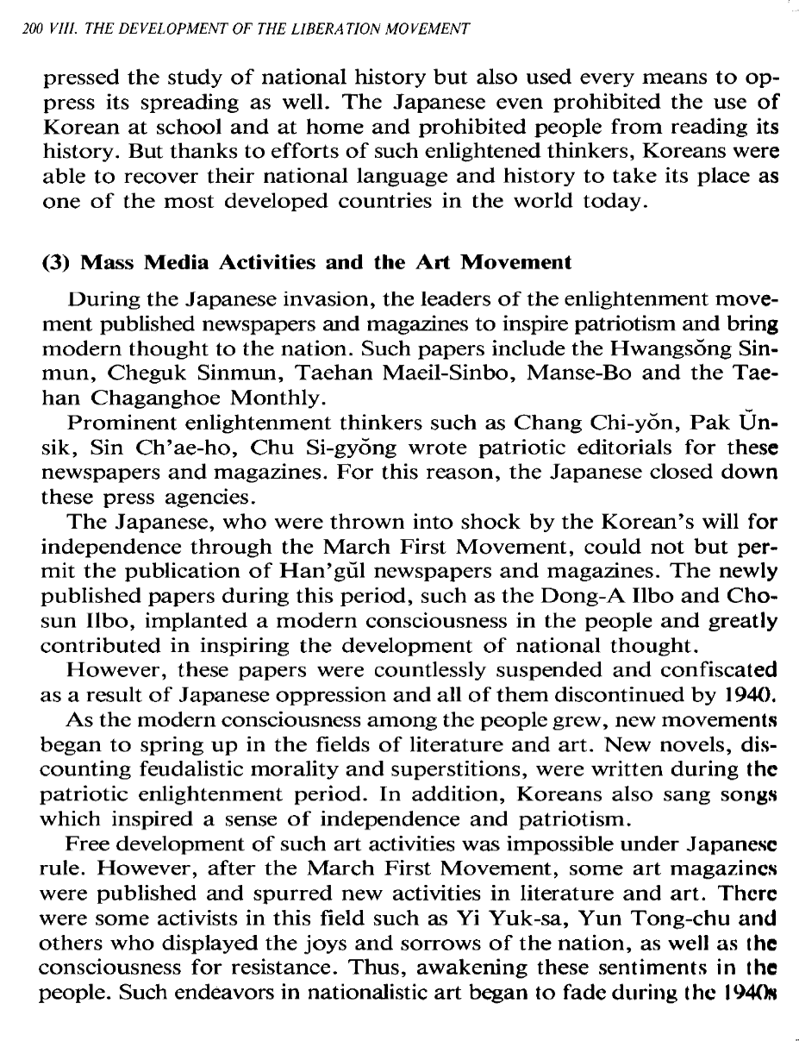
Resim 4 Radio Korea International Korean Broadcasting System. 1995. The History of Korea. Seoul
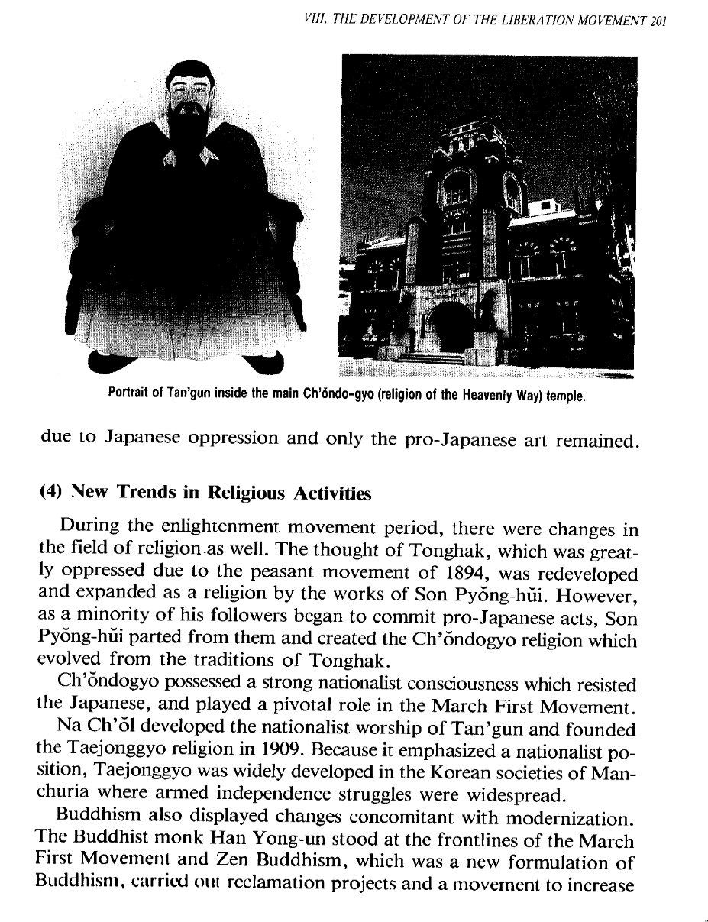
Resim 5 Radio Korea International Korean Broadcasting System. 1995. The History of Korea. Seoul
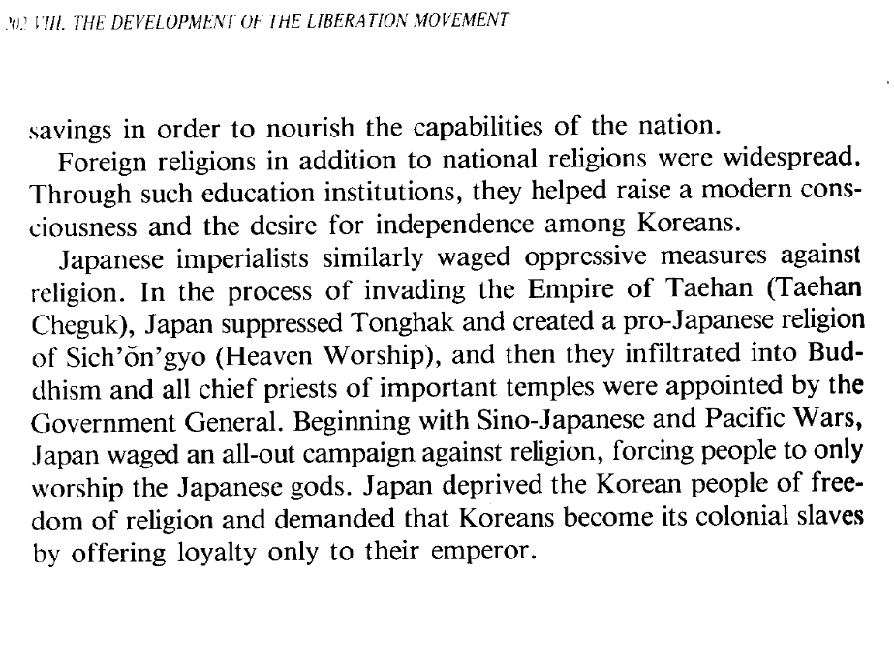
Resim 6 Radio Korea International Korean Broadcasting System. 1995. The History of Korea. Seoul

