Lipid Chemistry
Two most important functions of lipids are;
to be the source of energy (metabolic fuel) and constituents of cell membrane
Lipids are classified as simple and complex
- Simple lipids: waxes, fats and oils
- Complex lipids:phospholipids, glycolipids, sphingolipids
- Other complex lipids and derivatives: cholesterol,lipid-soluble vitamins and steroid hormones
Fatty acids
are long-chain unbranched carbons attached to a carboxyl group. Fatty acids have typically 12-18 carbon atoms.
They have the general formula CH₃-(CH₂)_{n}-COOH
Saturated fatty acids

- Acetic acid (C2:0 ) CH₃-COOH
Propionic acid (C3:0) CH₃-CH₂COOH
- Butyric acid (C4:0 ) CH₃-(CH₂)₂-COOH
- Caproic acid (C6:0 ) CH₃-(CH₂)₄-COOH
Caprylic (8 C ) CH₃-(CH₂)₆-COOH
- Capric (10 C ) CH₃-(CH₂)₈-COOH
Lauric acid (C12:0) CH₃-(CH₂)₁₀-COOH
- Myristic acid (C14:0) CH₃-(CH₂)₁₂-COOH
- Palmitic acid (C16:0) CH₃-(CH₂)₁₄-COOH
- Stearic acid (C18:0) CH₃-(CH₂)₁₆-COOH
- lignoceric acid (C24:0 ) CH₃-(CH₂)₂₂-COOH
Unsaturated Fatty Acids

C 16:1 Δ⁹ Palmitoleic acid
CH₃-( CH₂ )₅CH = CH-(CH₂)₇ –COOH
C 18:1 Δ⁹ Oleic acid
CH₃-(CH₂)₇- CH=CH – (CH₂)₇-COOH
C 18:2 Δ^{9,12} Linoleic acid
CH₃(CH₂)₄ CH=CHCH₂CH=CH(CH₂)₇ COOH
C 18:3 Δ^{9,12,15} Linolenic acid
CH₃CH₂CH=CHCH₂CH=CHCH₂CH=CH(CH₂)₇ COOH
C 20:4 Δ^{5,8,11,14} Arachidonic acid
CH₃(CH₂)₃ (CH₂-CH=CH)₄-(CH₂)₃ COOH
The melting point of unsaturated fatty acid is less compared to the saturated fatty acid.
Unsaturated fatty acids become liquid quickly at low temperatures.
- Double bond also increases cis-trans isomerism probability of the fatty acids.
Essential Fatty Acids
Linoleic and linolenic acids are essential fatty acids for human.
- ω–3 fatty acids are anti-inflammatory and have health benefits.
Eicosanoids
Eicosanoids derived from arachidonic acid (C_{20:4} ), have hormone like functions. Basic Eicozanoids
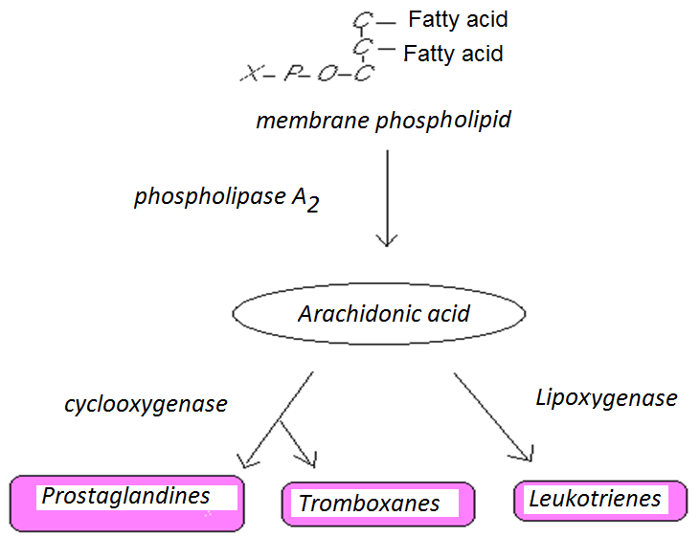
Eicozanoids have various effects
- Inflammation
- Reproductive functions
- Producing pain
- Rise in fever
- Blood clothing
- Regulation of blood pressure
- Secretion of stomach acid
Effects of Prostaglandins
- Effects the blood circulation
- İnduce smooth muscle contraction
- Regulates the neurophysiological mechanisms
- Regulates the sleep-wake cycle
- İncrease the body temperature
- Cause inflammation
- Cause pain
- Reduce stomach acid secretion
Tromboxans
Function in clothing
TXA2, synthesized by trombocyts, narrows the arteries
and triggers trombocyte aggregation.
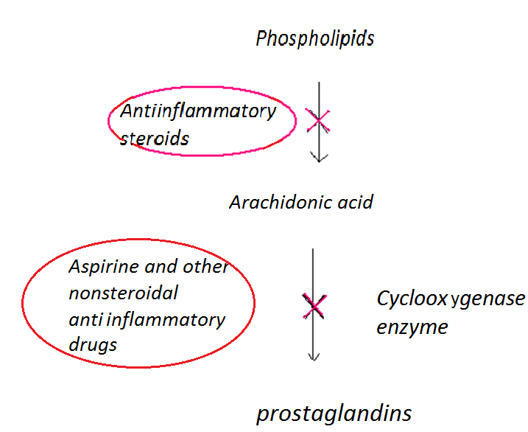

Aspirine and some antiinflammatory drugs are used to inhibit platelet aggregation in atherosclerosis.
- Leucotrienes
lead to the contraction of smooth muscles,
cause the contraction of pulmonary muscle coating,
facilitates chemotaxis, inflammation and allergic reactions
in the case of over production they cause asthma attacts.
Acylglycerolipids
- 1. Neutral lipids (Fats and oils)(Triglycerides)
- TAG s are potentially enegy stores.

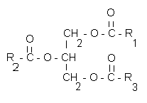
TAG in organism, are found in the cytoplasm of adipose tissue
The fatty acid profile determines whether the TAG will be liguid or solid.
- The melting point of even-numbered carbon fatty acids increase with chain length and decrease according to unsaturation.
Chemical features of Triglycerides
hydrolysis and saponification
Phospholipids
are triesters of glycerol in which two -ОН groups are esterified with fatty acids and one the third is esterified with phosphoric acid, which in turn is esterified to an alcohol.
Glycerophospholipids
are derived from gliserol 3-P

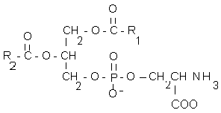 L- phosphatidylserine
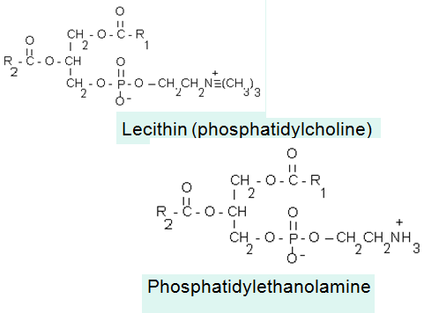

Phosphatidylinositol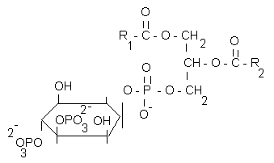
- R₁ : usually palmitic (C16:0) or stearic (C18:0) acid,
- R₂ :oleic (C18:1), linoleic (C18:2) or linolenic (C18:3) acid
Functions of Phospholipids
Structurel constituents of cell membranes
Because of their detergent like features they keep cholesterol in soluble state in bile.
Sphingolipids
are complex lipids involving a long chain amino alcohol sphingosine or dihydrosphingosine
- Ceramide is the most simple sphingolipid
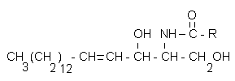
Other sphingolipids are formed by other groups attaching to C-1 OH of sphingosine.
for e.g. sphingomyelins 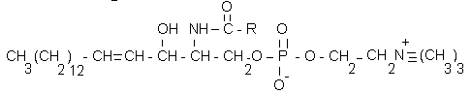
Glycolipids
They are lipids that contain carbohydrate residues with sphingosine as the alcohol and a very long-chain fatty acid (24 carbon series). They are membrane lipids containing glucose or galactose.

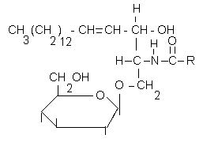 Glucoserebroside

Seramide Oligosaccharides
A glycosidic heterooligosaccaride is bound to seramide structure
Gangliosides, are complex glycolipids comprising a lot of sugar units bound to seramide, also carry at least one sialic acid residue (N-acetyl- neuraminic acid)
Waxes
- Wax is an ester of saturated fatty acid and long chain monohydroxy alcohol
are found in many plants and animals (or humans). Spermaceti oil Terpenes
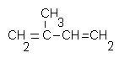
İsoprene
Compounds containing isoprene gives the flavour and scent of plants in nature.
Steroids
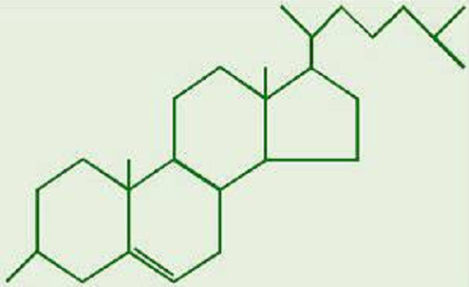

They carry cyclopentanoperhydrophenanthrene ring.
Cholesterol
Cholesterol, is an animal originated steroid
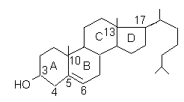

Cholesterol concentration in blood circulation is normally about 150–200 mg per 100 ml of serum.
Since cholesterol is insoluble in blood, it is transported in the circulatory system within lipoproteins like LDL, VLDL.

Cholesterol solubility in bile is provided by:
1. phospholipids
2. bile salts

Biofunctions of Cholesterol
It is a minor component of cell membranes.
It serves as the body’s starting material for the synthesis of all other steroids, including the sex hormones, bile salts and vitamin D.
The end products of cholesterol utilisation are the bile acids.
The function of bile acids is to facilitate the digestion and absorption of TAG and fat-soluble molecules; vitamins in the diet.

Biofunctions of Bile Acids
-Solubilizing cholesterol in bile and prevent gall stone formation.
-increasing intestinal motility
-Help in digestion of the other foodstuffs.
-Activation of pancreatic lipase.
-Help digestion and absorption of fat and fat-soluble vitamins.
-Emulsification of lipids during digestion.
Lipids in serum of blood:
- Lipids are transported in the circulation packaged in lipoproteins.
From lowest to highest density (rich in lipid and triglyceride, poor in protein) these are:
Chylomicrons, Prebeta-lipoproteins,
very low-density lipoprotein (VLDL)
Beta-lipoproteins low-density lipoprotein (LDL),
and alpha-lipoproteins, high-density lipoprotein (HDL).
Fatty acids however are found in the circulation as bound to albumin.

