**Vitamin A**

Vitamin is present in foods are as vitamers and precursors. The most important vitamer is retinol (vitamin A1, all trans retinol) (see figure 1).

Plants contain [carotenoids](http://lpi.oregonstate.edu/mic/dietary-factors/phytochemicals/carotenoids), some of which are precursors for vitamin A (e.g., β-carotene, the most potent)   
This molecule in humans is *broken* down during absorption yielding 2 molecules of retinal. Retinal is in equilibrium with retinol in the cell (see figure 1).



Figure 1

The main physiological role is in vision, also is important for mucus secretion, epithelial cell differentiation, collagen, immune function, protection of membrane integrity, growth and reproduction.  
Retinoids and retinoic acid have anticancerogen activity. β-carotene is an antioxidant. Retinoic acid is being used for the treatment of acne also is important for glycolysation.

When the lihgt comes to retina it is absorbed by pigments.  
The [retina](http://lpi.oregonstate.edu/mic/glossary) contains two main types of light-sensitive [receptor](http://lpi.oregonstate.edu/mic/glossary) cells − known as rod and cone photoreceptor cells. These cells have a visual pigment called rhodopsin composed of opsin and retinal. Rhodopsin gets broken to opsin and all trans retinal by the photon (this is the only step catalysed by light in sight; vision)   
Rhodopsin is regenerated in the dark, 11 cis retinal combine with opsin to form rhodopsin. Rhodopsin is reduced with the deficiency of the vitamin.

Requirement:  
800- 1000 µg Retinol equivalent

(4000-5000 IU)  
 1 U = 0,3 µg Retinol

Much of retinol ve retinal is toxic

Pregnants must not consume more than 6000 IU/day.

Deficiency:

First symptom is the nightblindness; nyctalopia.

The deficiency also leads to delay of growth, sensitivity to infections, epidermal lesions and infertility.

Vitamin D

is necessary for healty teeth and bones  
-is metabolized in the kidney to the metabolically active form called 1,25-dihydroxyvitamin D; calcitriol hormone that plays a central role in Ca and phosphate metabolism.  
Vitamin D can be [synthesized](http://lpi.oregonstate.edu/mic/glossary) in the skin upon exposure to sunlight, no need to take from foods.  
Vitamin D3 is not synthesized by plants and microorganisms.

Vitamin D3 is the natural vitamin, synthesized from 7-dehydrocholesterol in the skin by uv light and is found in fish oil. It binds to DBP (D binding protein) for the transport, storage and distribution in the body.

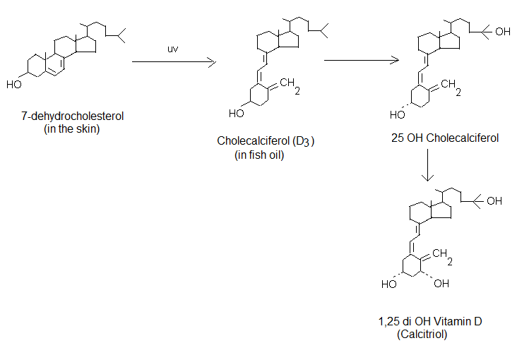

Vitamin D2 (ergocalciferol) is synthesized from ergosterol (found in food) upon exposure to uv

Sources

Fish oil, egg and liver are good sources.  
Milk, butter and other foods are routinely fortified with D2 prepared by irradiating ergosterol from yeast.

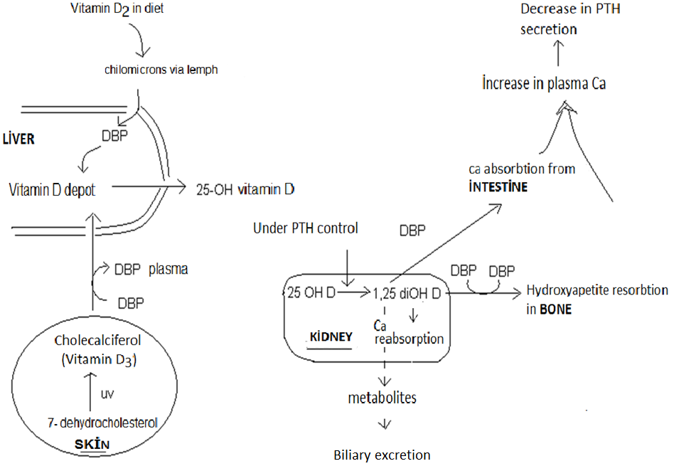

Figure 3  
  
Cholecalciferol, either synthesized in the skin or from food undergoes two hydroxylations to yield the active metabolite 1,25-dihydroxy vitamin D (calcitriol hormone) (see figure 3).  
 25-dihydroxyvitamin D is in turn converted into the biologically active form; 1,25-dihydroxycholecalciferol (also called calcitriol) in the kidney.

The most potent form is 1,25-dihydroxyvitamin D, goes to target tissues plays a role in Ca2+ and phosphate regulation.  
  
1,25-diOH D acts in concert with parathormon (PTH), which is also produced in responce to low serum Ca2+. PTH plays a major role in regulating the activation of vitamin D. High PTH stimulate the production of 1,25-diOH D. Effects of 1,25 diOH vitamin D:

The principal function of vitamin D is to maintain the plasma ca concentration.

Once formed, , it acts as a typical steriod hormone in:  
1. intestinal mucosal cells, increases the ca and phosphate absorbtion from intestine

2. in bone, mobilizes bone mineral;

3. 1,25-diOH D and PTH inhibit ca excretion in the kidney by stimulating calcium reabsorption in the distal renal tubules

By this way the ca ions in plasma is increased immediately.  
The excess of vitamin is excreted by the bile.

Vitamin D in physiological concentration together with PTH increase bone resorption; do ca mobilisation (demineralisation) by stimulating osteoblast formation and activity. Vitamin transfers Ca and phosphate from the old (worn) bone tissue to the newly forming bone area.  
  
Therefore vitamin D increases the bone formation of epiphysis and mineralisation in developing body (during growth).

It increases the mineralisation and tissue renewal in adults.  
In the deficiency state vitamin can not mobilise Ca but on the other hand increases the resorption, resulting in Ca increase in fluids of body.  
In the case of high vitamin intake, the mobilisation of Ca from bone can not be equilibriated. If this high intake continue, then Ca lost from bone and atrophy and osteoporosis occurs.

Rickets and osteoporosis occur when the diet is deficient in Ca and/or because of the deficient Ca resorption from intestine.  
Even if Ca2+ ve PO4 are adequate in the diet the absorbance of Ca will not be efficient in the case of 1,25 DiOH cholecalciferol deficiency.  
  
Vitamin D deficiency

The most common symptoms of vit D deficiency is rickets in young children and osteomalacia in adults.

Daily requirement

200-400 IU or 5-10 µg (1 µg =40 IU)

Toxicity: >4000 IU is toxic

Must be consumed less than 1000 IU/day

Vitamin E

8 isomers of vitamin E are present in plants. Tocopherols are derivatives of tocol ve tocotrienols. The most potent is α-tocopherol.

Structure of tocopherols



R1 R2 R3

Sources

Widely distributed in plant kingdom.

Vitamin E found in the membranes is the most important antioxidant.

Protects the mebrane from lipid peroxidation . Vitamin E is a chain breaking antioxidant of lipid peroxidation.

Vitamin E protects artery walls and keeps LDL cholesterol from being oxidized. Oxidation of LDL cholesterol marks the beginning of clogged arteries. It protects the skin from uv light.

Deficiency

Vitamin E deficiency is rare. Cases of vitamin E deficiency usually occur in premature infants and in those unable to absorb fats (chronic fat malabsorbtion) also in abetalipoproteinemia.

RDA: 15mg/day.

Vitamin K

Vitamin K is naturally produced by the bacteria in the intestines, and plays an essential role in normal blood clotting, promoting bone health

Less is known about its deposition which is limited due to its fast turnover.

Structure of Vitamin K

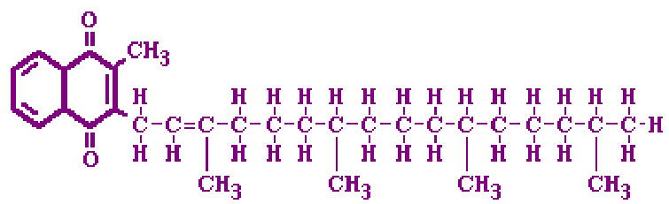

Vitamin Kı (phylloquinone)

Found in vegetable oils, green leafy vegetables

Vitamini K2 (menaquinone) is found in animal tissue and bacteria

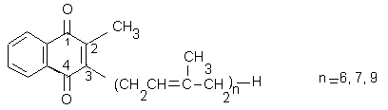

Vitamin K is a coenzyme in gamma carboxylation reactions. These carboylations are important for blood coagulant factors (Protrombin (factor II), VII, IX and X ), and also other proteins like osteocalcin in bone. The carboxylated protein can bind Ca and become activated.  
  
Vitamin K in some proteins, plays a role in e- transfer and forming γ-carboxyglutamyl from glutamyl residues

Oral anticoagulants inhibit the regeneration of vitamin K by inhibiting epoxide reductase thereby inhibits the synthesis of clothing factors.

Inability to activate the clotting cascade via these factors leads to the bleeding symptoms. Hemorrhagy can occur.   
Vitamin K deficiency;

rarely seen, however

– in newly born  
– fat malabsorbtion  
- oral anticoagulant theraphy  
- long term antibiotic theraphy  
-chemotheraphy

- Warfarin intoxication causes deficiency.

Daily requirement

Some of vitamin K is synthesized by the intestinal bacteria but this is not enough for the daily requirement. Due to the unknown levels synthesized in the intestine, an absolute RDA value can not be given.