1.Hafta

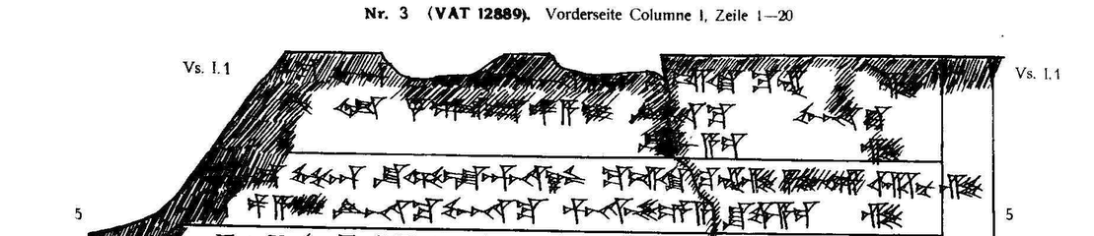

1 [ták-ku LÚ-an n]a-aš-ma MUNUS-an [šu-ul-la-a]n-na[-a]z ku-iš-ki ku-en-zi
2 [a-pu-u-un ar-nu-z]i Ù 4 SAG.DU pa-a-i LÚ-na-ku MUNUS-na-ku
3 [pár-na-aš-še-e-a] šu-wa-a-ez-zi
4 [ták-ku ARAD-an] na-aš-ma GÉME-an šu-ul-la-an-na-az ku-iš-ki ku-en-zi a-pu-u-un ar-nu-zi
5 [Ù 2 SAG.D]U pa-a-i LÚ-na-ku MUNUS-na-ku pár-na-aš-še-e-a šu-wa-a-ez-zi

