7.Hafta 29-36
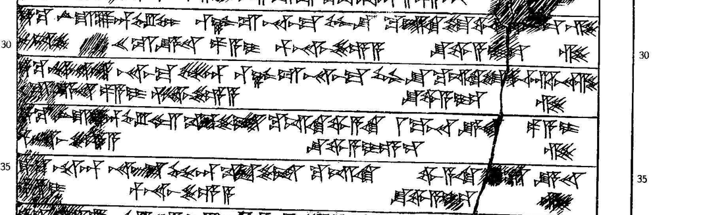

29 ták-ku LÚ.U₁₉.LU-an EL-LUM QA-AZ-ZU na-aš-ma GÌR-ŠU ku-iš-ki tu-wa-a[r-n]i-iz-zi
30 nu-uš-še XX GÍN KÙ.BABBAR pa-a-i pár-na-aš-še-e-a šu-wa-a-i-iz-zi
31 ták-ku ARAD-an na-aš-ma GÉME-an QA-AZ-ZU na-aš-ma GÌR-ŠU ku-iš-ki tu-wa-ar-na-zi
32 X GÍN KÙ.BABBAR pa-a-i pár-na-aš-še-e-a šu-wa-a-i-iz-zi
33 ták-ku LÚ.U₁₉.LU-an EL-LAM KIR₁₄-še-et ku-iš-ki wa-a-ki I MA.NA KÙ.BABBAR pa-a-i
34 pár-na-aš-še-e-a šu-wa-a-i-e-ez-zi
35 ták-ku ARAD-an na-aš-ma GÉME-an KIR₁₄-še-et ku-iš-ki wa-a-ki III GÍN KÙ.BABBAR
36 pa-a-i pár-na-aš-še-e-a šu-wa-a-i-iz-zi

