Classification of fatty acids
Depending only on chain length they can be functionally divided into:
- Short chain fatty acids: Up to 6 carbon atoms
- Medium chain fatty acids: From 8 to 12 carbon atoms;
- Long chain fatty acids: From 14 to 20 carbon atoms;
- Very long chain fatty acids: From 20 carbon atoms onwards
Moreover, on the basis of the absence/presence of double bonds they can be grouped into two broad classes:
- Saturated fatty acids, if there are no double bonds in the carbon chain;
- Unsaturated fatty acids, if there are one or more double bonds in the carbon chain.
Saturated fatty acids are ‘filled’ (saturated) with hydrogen. Most saturated fatty acids are straight hydrocarbon chains with an even number of carbon atoms. The most common fatty acids contain 12 to18 carbon atoms. They are stable to oxidation as a result of the saturation of their carbon chain. 2-8 carboned fatty acids are liquid form at room temperature. 2-12 carboned have sharp smell. As their carbon numbers increase, their melting and boiling points gets also higher. CH₃ (CH₂)_{n} is their general formula.
C number |  |  | Name
2 | Water soluble | Volatile | Acetic Acid
4 |  |  | Butyric acid
6 |  |  | Caproic acid
8 |  |  | Caprylic acid
10 | Water insoluble |  | Capric acid
12 |  |  | Lauric acid
14 |  | Non-Volatile | Myristic acid
16 |  |  | Palmitic acid
18 |  |  | Stearic acid
20 |  |  | Arachidic acid

Unsaturated fatty acids contain one or more double carbon-carbon bonds in the carbon chain. They are liquid at room temperature, and they have low melting points. Monounsaturated fatty acids have one carbon–carbon double bond, whereas polyunsaturated fatty acids (PUFA), have two or more double bonds. These fatty acids are also characterized by the presence of cis-trans configuration at their double bonds. Cis means that the hydrogen atoms on either side of the double bond are oriented in the same direction if the hydrogen atoms are in opposite sides, then it is defined as trans configuration. In nature, cis configuration is the most common one for unsaturated fatty acids. Cis bond causes a bend in the fatty acid chain, whereas the geometry of trans bond straightens the fatty acid chain, imparting a structure more similar to that of saturated fatty acids. The cis fatty acids have lower melting points than the trans fatty acids or their saturated counterparts.
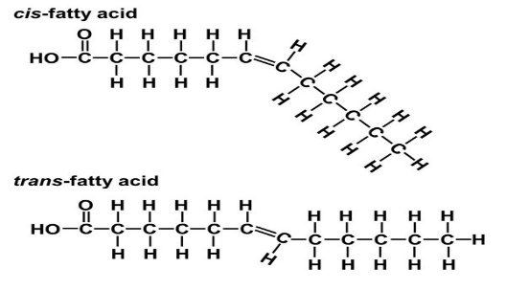
There are two broad types of trans fats found in foods: naturally-occurring and artificial trans fats. Naturally-occurring trans fats are produced in the gut of some animals and foods made from these animals (e.g., milk and meat products) may contain small quantities of these fats. Artificial trans fats (or trans fatty acids) are created in an industrial process that adds hydrogen to liquid vegetable oils to make them more solid. Trans fats have a melting point, consistency and “mouth feel” similar to those of butter, a long shelf life at room temperature, a flavor stability and they are stable during frying. Because of these properties they are used in food industry. They can be found in many foods – including fried foods like doughnuts, and baked goods including cakes, pie crusts, biscuits, frozen pizza, cookies, crackers, and stick margarines and other spreads. But the primary dietary source for trans fats in processed food is partially hydrogenated oils. According to the researches trans fats raises bad (LDL) cholesterol levels and lower good (HDL) ones. Eating trans fats increases the risk of developing heart disease and stroke. It’s also associated with a higher risk of developing type 2 diabetes. On 2003 FDA ruled that food labels, for conventional foods and supplements, show their content. On 2006 American Heart Association recommended to limit their intake to 1% of daily calorie consumption, and suggested food manufacturers and restaurants switch to other fats.
Hydrogenation: Is a chemical reaction in which hydrogen atoms react, in the presence of a catalyst, with a molecule. The hydrogenation of unsaturated fatty acids involves the addition of hydrogen atoms to double bonds on the carbon chains of fatty acids. The reaction occurs in presence of high temperature, pressure and catalyst. Nickel or cadmium can be used as a catalyst. By this process the oils are converted into solid fats (glycerides of saturated fatty acids) so their thermal and oxidative stability can increase. Partially hydrogenated vegetable oils were developed for the production of vegetable fats, a cheaper alternative to animal fats. In fact, through hydrogenation, oils such as soybean, safflower and cottonseed oils, which are rich in unsaturated fatty acids, are converted into semi-solid fats. But most importantly during this process trans fats are formed. Margarine is one of the most common product, which is produced by hydrogenation. They contain generally 13-20 % trans fatty acids.
On the basis of the ability or not to synthesize them in our body, fatty acids can be divided into two groups essential and non-essential fatty acids. Essential fatty acids cannot be synthesized in our body, so we need to take them on our diet. All the other fatty acids can be synthesized or converted in our body. Essential fatty acids are polyunsaturated fatty acids (PUFAs) since they contain two or more double bonds and our body can only synthesize fatty acids have one double bond. There are two essential fatty acids: linoleic acid or (LA) and α-linolenic acid (ALA). LA and ALA can be elongated and desaturated into the functionally important longer chain omega-6 and omega-3 fatty acids. ALA (18 carbons) can be converted into a small amount of eicosapentaenoic acid (EPA-20 carbons) and even less docosahexaenoic acid (DHA-22 carbons). LA is converted to arachidonic acid. The body uses essential fatty acids for the formation of healthy cell membranes, the proper development and functioning of the brain and nervous system, and for the production of hormone-like substances called eicosanoids (thromboxanes, leukotrienes, and prostaglandins). These chemicals regulate numerous body functions including blood pressure, blood viscosity, and vasoconstriction, immune and inflammatory responses. Omega-6 fatty acids are found in leafy vegetables, seeds, nuts, grains, and vegetable oils (corn, safflower, soybean, and cottonseed, and sesame, sunflower). The best source of ALA is flaxseeds or flaxseed oil. For those seeking to increase their intake of omega-3 fats, more concentrated sources can be found in oils such as canola, soybean, walnut, and wheat germ. In the human diet, EPA and DHA derive from fish, shellfish and fish oil particularly that derived from cold-water fatty fish. The balance between omega-6 and omega-3 in the diet seems to be crucial for a better human health. According to WHO for every 10-15 g of omega-6 fatty acids, 1 g of omeg-3 should be consumed.

Chemical Properties of Lipids

Esterification: Reaction between alcohol and the carboxyl group of the fatty acids.
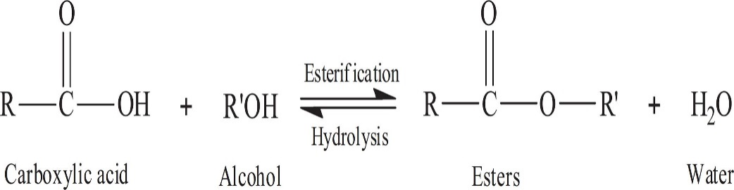
Saponification: Hydrolysis of lipids with alkalines (KOH or NaOH). Saponification number is the number of milligrams of KOH required to saponify the free and combined fat in 1 gram of a given fat. By this property of lipids fraud in a lipid can be found. Every lipid has a specific saponification number.
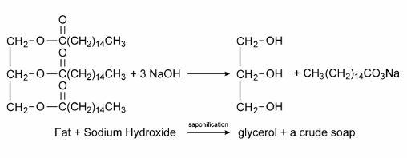
Acrolein Forming: When heated in the presence of potassium hydrogen sulfate, glycerol dehydrated and form acrolein. Acroleins have unpleasant odor.
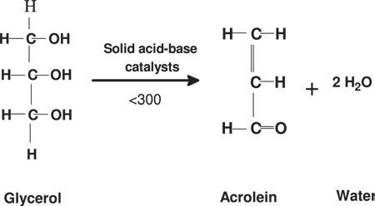

Binding Halogens: Halogens, like iodine, can bind to the double bonds of unsaturated lipid. This property shows the origin of the lipid by iodine number.
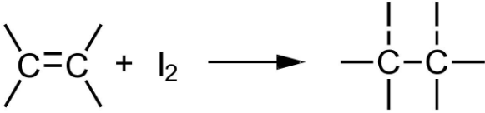
Rancidity (Oxidation of lipids)
Lipid oxidation is one of the major reasons that foods deteriorate and is caused by the reaction of fats and oils with molecular oxygen leading to off-flavors that are generally called rancidity. Rancidity is the development of unpleasant smells in fats and oils, which are often accompanied by changes in their texture and appearance. There are two major causes of rancidity. One occurs when oil reacts with oxygen and is called oxidative rancidity. The other cause of rancidity is by a combination of enzymes and moisture. Enzymes such as lipases liberates fatty acids from the triglyceride to form di and/or monoglycerides and free fatty acids and such liberation of free fatty acids is called hydrolysis. Rancidity caused by hydrolysis is called hydrolytic rancidity. Factors effecting the rancidity are; fatty acid composition, temperature, antioxidants and light.
Hydrolytic rancidity, can affect saturated and unsaturated lipids. The reaction occurs without oxygen but in the presence of moisture and accelerated by temperature (increase) or a catalyst. These catalysts are usually enzymes (lipase, esterase, lipoxygenase, cyclooxygenase, etc.) or acidic in nature. It is formed more in animal fats than vegetable oils.
Oxidative rancidity seen in unsaturated lipids. Oxygen binding to the double bonds. Reaction occurs in a series of steps. Initiation step is slow and triggered by light, metals, temperature. Propagation step is ırreversible and free radicals are stars to form. Termination step, aldehydes and ketones forms which gives the characteristic off-flavors and odors.

Emulsion
Emulsion is a special type of mixture made by combining two liquids that normally don't mix. The word emulsion comes from the Latin word meaning "to milk", milk is one example of an emulsion of fat and water. An emulsion consists of two immiscible liquids (usually oil and water), with one of the liquids being dispersed as small spherical droplets in the other. The droplets are termed the dispersed phase, and the liquid that contains them is termed the continuous phase. The process of turning a liquid mixture into an emulsion is called emulsification.
Emulsions can be conveniently classiﬁed according to the relative spatial distribution of the oil and aqueous phases. A system that consists of oil droplets dispersed in an aqueous phase is called an oil-in-water (o/w) emulsion, for example, milk, cream, dressings, mayonnaise, beverages, soups, and sauces. A system that consists of water droplets dispersed in an oil phase is called a water-in-oil (w/o) emulsion, for example, margarine and butter.
Emulsions are colloidal systems because of the size and surface area of the droplets. They are unstable structures and phase separation can easily occur. For this reason, need emulsifiers to stabilize the mixture and keep the different ingredients from becoming separated. Emulsifiers coats the emulsion droplets and prevents them from coalescing or recombining with each other. They have one hydrophilic and one lipophilic part. Emulsifiers work by increasing the kinetic stability of a mixture. Surfactants or surface active agents are one type of emulsifiers. Detergents are another example of a surfactant. Natural emulsifying agents are derived from plant and animal tissues and mostly in the form of hydrated lipophilic colloids. Other examples of emulsifiers include lecithin, mustard, soy lecithin, sodium phosphates, diacetyl tartaric acid ester of monoglyceride (DATEM), and sodium stearoyl lactylate.

