Biological Molecules
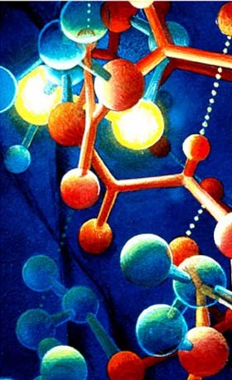
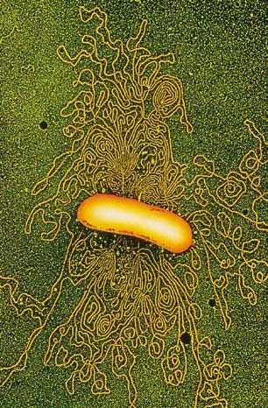
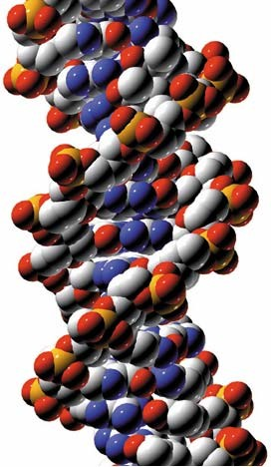

1

Of the 92 naturally occurring elements, 16 are known to be important constituents of living systems.

The important elements are
C, H, O, N, P, S, K, Ca, Na, Cl, Mg, Fe, Cu, I, Mo, Zn

By dry mass:
O - 63%, C-20%, H-10%, N-2.5% Ca-2.5% P- 1.1% C+H+O+N = 96%
Cl, Fe, S, K, Na < .2% Mg, Cu, I, Mo, Zn < .1%

2

All important biological molecules contain carbon
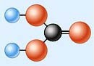
All molecules that contain carbon are called organic (except for CO2). All other molecules are .
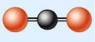
Carbon forms 4 covalent bonds. This allows carbon to form molecules with many different shapes.

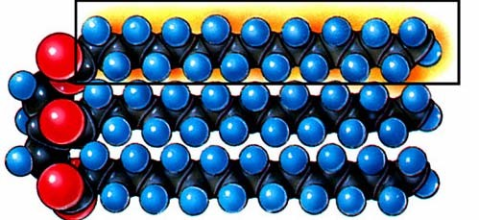
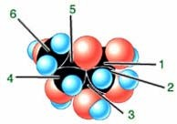

3

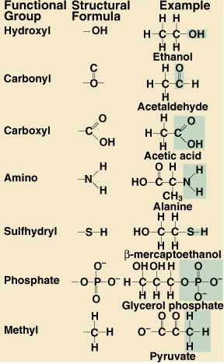

Most biological molecules have a core made of carbon and hydrogen. Molecules differ in structure and function, in part, because of different functional groups.

4

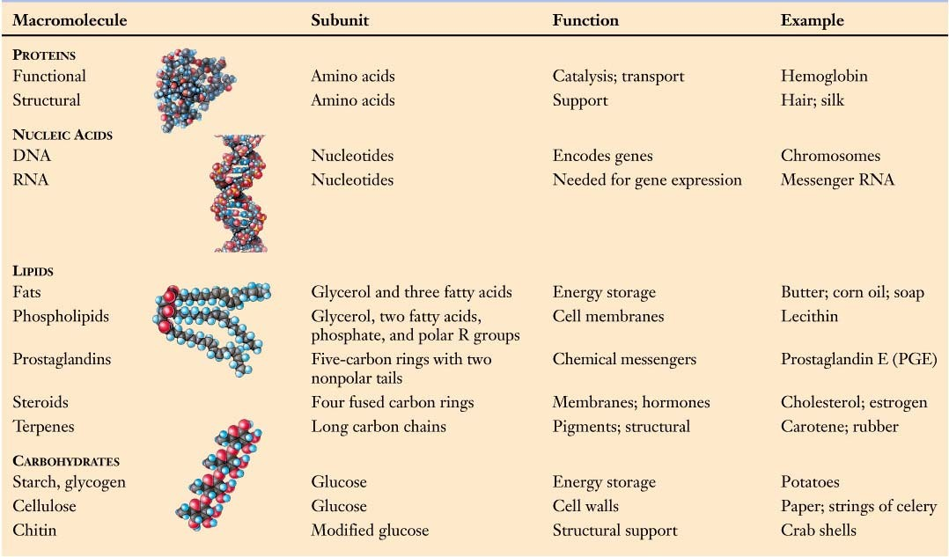
The major classes of biological molecules that are important for all living things are carbohydrates, lipids, proteins, and nucleic acids. Large biological molecules are called macromolecules.
5

Macromolecules are built by combining smaller building blocks into polymers.
Polysaccharides (large carbohydrates) are polymers of monosaccharides.
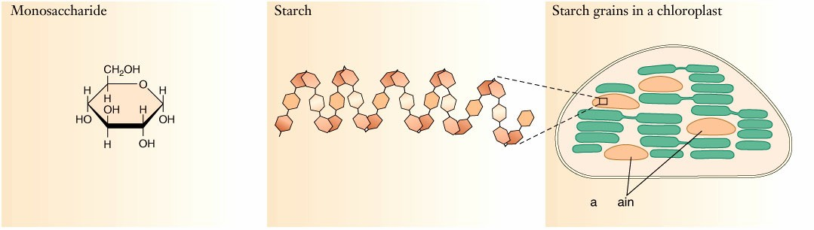
Fats are built from fatty acids and glycerol.

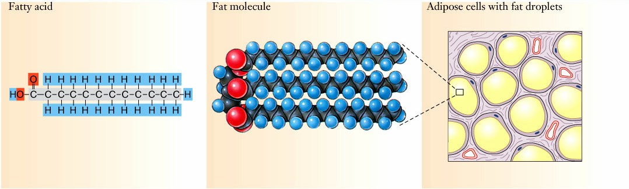
6

Proteins are polypeptides - polymers of amino acids.
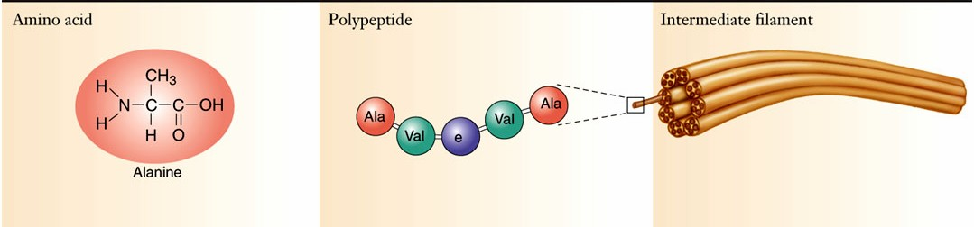

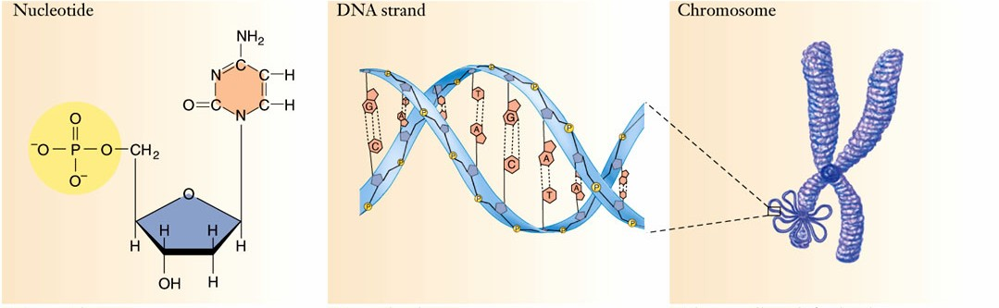
Nucleic acids are polymers of nucleotides.

7

Carbohydrates - compounds made of C, H, and O in a ratio of

examples: all sugars, starches, cellulose and chitin Carbohydrates are used for energy storage and structures. Carbohydrates have a caloric value of 4.1 kilocalories/gram.

An aside on calories:
A calorie is the amount of heat required to raise 1 g of water 1°C. A kilocalorie is the amount of heat required to raise 1 kilogram of water 1°C or 1 gram of water 1000°C.
A Calorie is a dietary unit of energy equal to a kilocalorie. One gram of sugar has 4.1 Calories and 4.1 kilocalories.

8

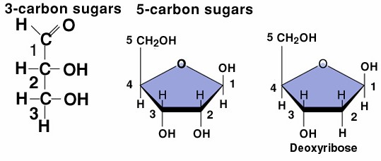The simplest class of carbohydrates are monosaccharides - simple sugars - All have 3 to 6 carbons
Glyceraldehyde
Ribose
6-carbon sugars

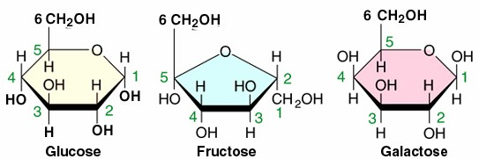
9

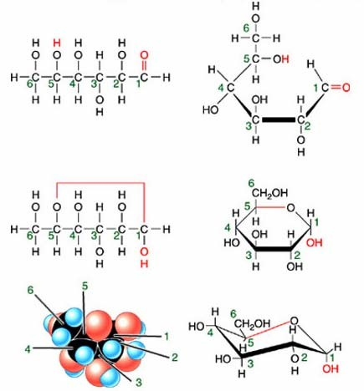Simple sugars exist in different forms and can be drawn in different ways.
Glucose

10

The six carbon sugars all have the same chemical formula: C6H12O6
They differ in the placement of functional groups C=O and -OH
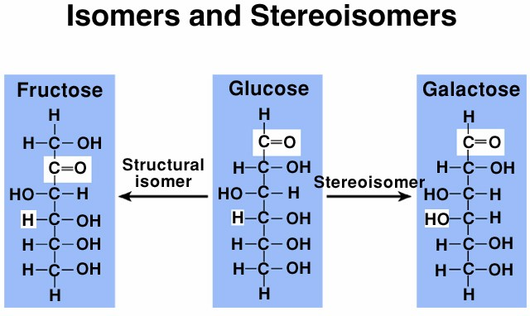
Isomers have the same chemical formula. Stereoisomers differ in the arrangement of a functional group at a single carbon.

11

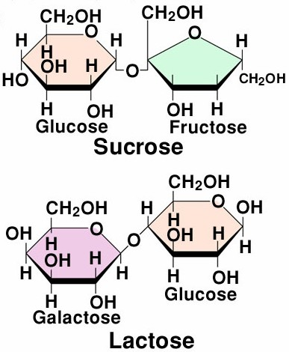
Monosaccharides are the building blocks of more complex carbohydrates

are a combination of two monosaccharides.

12

Disaccharides are formed by dehydration synthesis or a
.

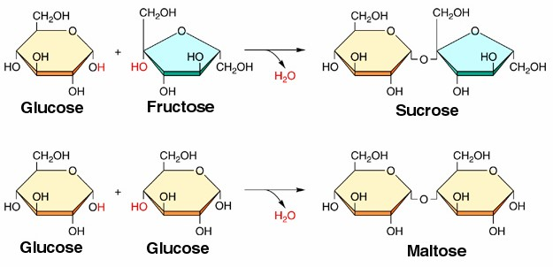

13

Many of the larger biological molecules are built by combining smaller molecules (building blocks) through dehydration synthesis reactions
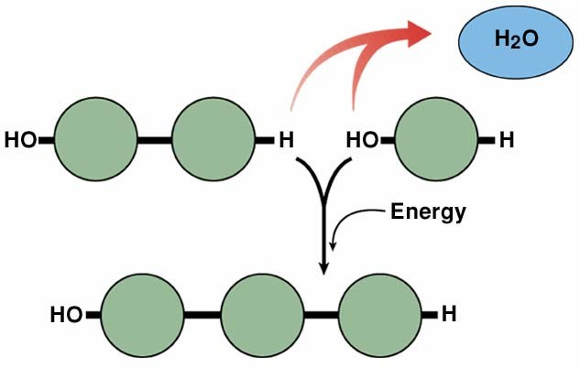

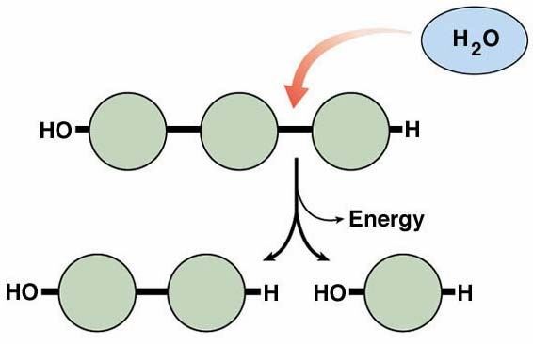
and the same molecules can be broken apart into their component building blocks by
reactions.

14

Polysaccharides are polymers of monosaccharides. Polymers are long chain molecules with repeating subunits.

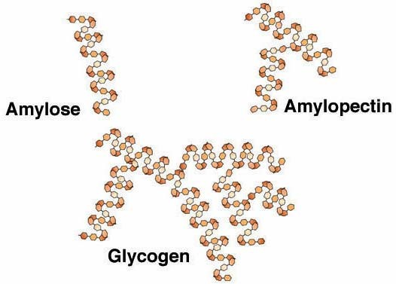
Starches are polymers of glucose.
Starches are used for
.
Each glucose molecule is an energy rich molecule.

Amylose is an unbranched chain and is produced by plants. Amylopectin is branched and also produced by plants.
Glycogen is highly branched and produced by animals. 15

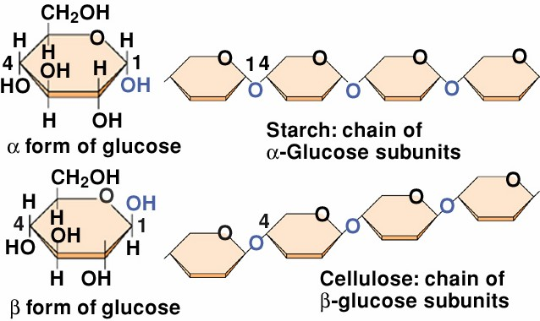
Polymers of the two stereoisomers of glucose produce polymers with very different properties

Starch is a polymer of
α-glucose and readily
digestible
Cellulose is a polymer of
β-glucose and indigestible
Cellulose is a structural polysaccharide and used for the construction of cell walls in plants.

16

Another important structural polysaccharide is chitin. Chitin is a polymer of β-glucose molecules that have a nitrogen containing functional group.

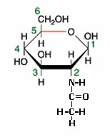
Chitin is also indigestible.
It is used to build cell walls in fungi and to build exoskeletons in arthropods.
Even though chitin does not strictly follow the 1C : 2H : 1O rule for carbohydrates it is still classified as a structural polysaccharide.

17

Lipids - a chemically diverse class of organic molecules that are grouped together because they are all largely nonpolar. Because they are nonpolar they are soluble in organic solvents like chloroform, benzene, acetone, paint thinner, etc. and insoluble in water

The major classes of lipids are fatty acids, neutral fats, phospholipids, steroids (or sterols).

Lipids have many functions including energy storage, cell membrane structure, vitamins (biochemical helpers) and hormones (substances produced in one part of the body that have effects on other parts of the body).

18

Fatty acids are long-chain carbon molecules with many carbon- hydrogen bonds and a carboxyl group (COOH) on one end. The carboxyl group can ionize, releasing an H+.
They come in two varieties saturated and unsaturated.
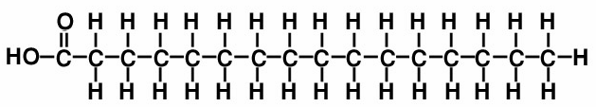
Saturated fatty acids have no C=C bonds - all carbons in the chain are bonded to as many hydrogens as possible.
Unsaturated fatty acids have some C=C bonds in the chain - the carbon chain is not completely saturated with hydrogens.

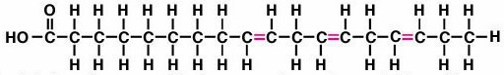
19

Fatty acids are a component of two other classes of lipids -
neutral fats and phospholipids.
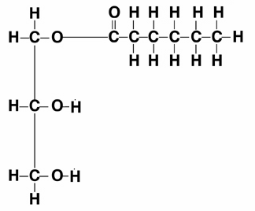
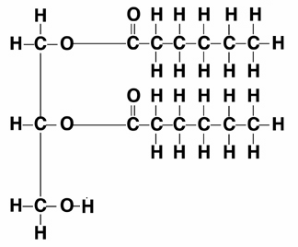
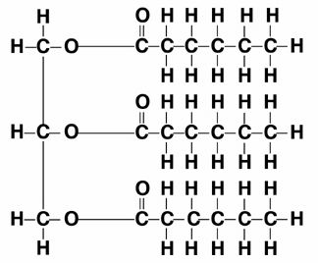
Neutral fats are molecules composed of glycerol (a sugar alcohol) and 1, 2, or 3 fatty acids.

Neutral fats are used for long-term energy storage.
They have a caloric value of 9.5 kcal/g.
20

Neutral fats are called saturated fats if their fatty acid chains are saturated. They are called unsaturated fats if one or more chains are unsaturated fatty acids. They are called polyunsaturated if they have many C=C bonds in their fatty acids chains.
Saturated fats have a regular structure, pack tightly, and form solids at room temperature.
Most animal fats are of this type.

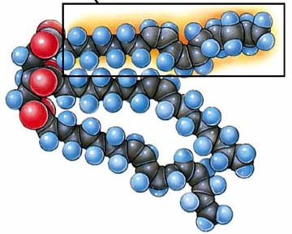
Unsaturated fats have an irregular structure, do not pack tightly and are liquid at room temperature. They are oils.
Most plant fats are of this type.

21

Phospholipids - structural lipids - an integral part of cell membranes - inside and enclosing cells.
22
Structurally similar to triglycerides - one fatty acid is replaced by a choline group. The choline group has both N and P in its structure.
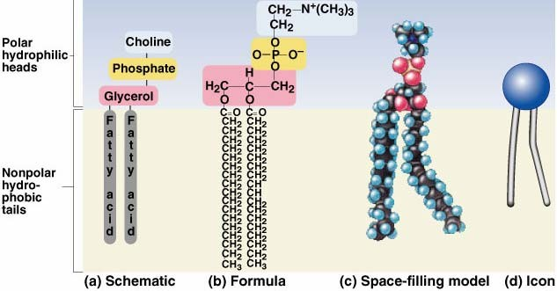

The choline group is charged (polar) and will hydrogen bond with water. It is called hydrophilic (water loving).
The rest of the molecule is nonpolar and insoluble in water. It will not hydrogen bond with water. It is hydrophobic (water fearing). Because phospholipids have two very different tendencies toward water they are called .

23

The choline end of the molecule is called the “head.” The fatty acid chains are called the “tails.” Phospholipids have hydrophilic heads and hydrophobic tails.
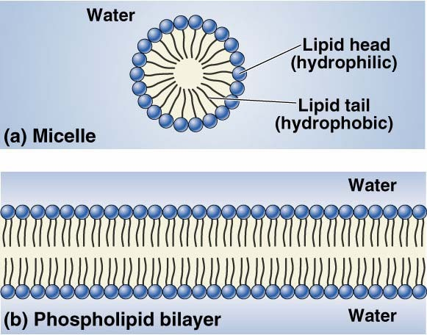
In water, phospholipids spontaneously form micelles or bilayers with their heads pointing outwards and their tails associating with each other and avoiding water.

24

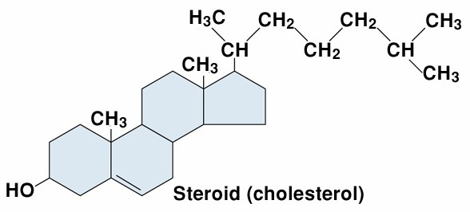
Steroids or Sterols - have a more complex structure than other lipids and a greater diversity of functions.

Cholesterol is an important part of cell membranes

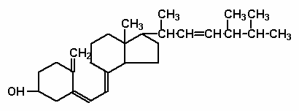Vitamin D is necessary for some biochemical reactions to occur properly.
Vitamin D
Deficiencies result in skeletal abnormalities.
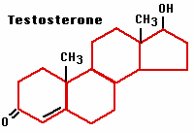
Other steroids are hormones. The sex hormones, testosterone, estrogen and progesterone are steroids.
25

Proteins - the most functionally diverse class of biological molecules - Protein diversity is the basis of the diversity of life. Everything that organisms are composed of - all parts - are made of, or by proteins.

Proteins serve as enzymes (biological catalysts), for defense, transport, support, motion, regulation, and storage.
Proteins have a gross caloric value of 5.7 kcal/g but metabolism of proteins creates toxic nitrogenous waste that must be processed for excretion from the body. There is about a 0.9 kcal/g cost in processing. Thus proteins have a net caloric value of 4.8 kcal/g.

Because of the toxicity of the byproducts of protein metabolism, proteins are not a good food source for providing energy. Proteins are a necessary foodstuff for building new proteins.

26

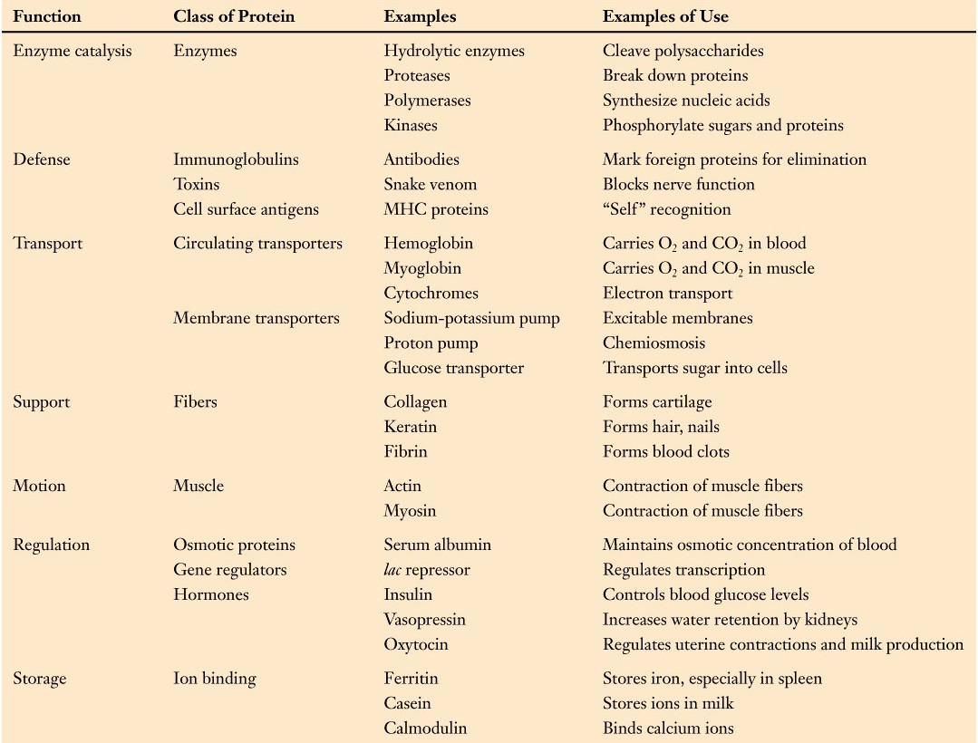
27

Proteins are polymers of amino acids
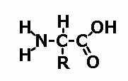There are 20 different amino acids used in proteins. All have a similar structure. All have a central carbon, an amino group (NH2) and a carboxyl group (COOH).

The 20 different amino acids each have a different R group.

28

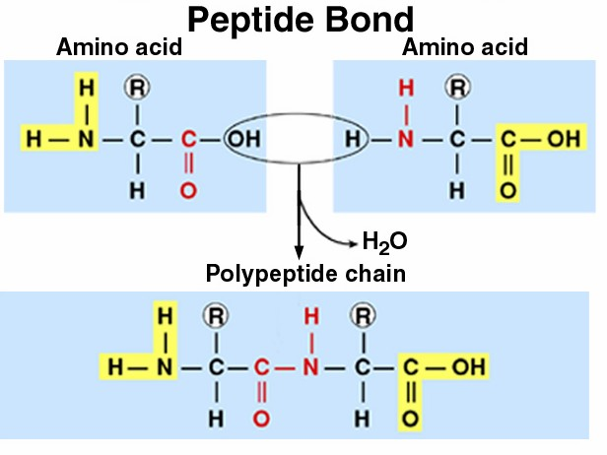
Proteins are polymers of amino acids joined through peptide bonds.

A polymer of amino acids is called a polypeptide. All proteins are polypeptides. Not all polypeptides are proteins. A protein is a polypeptide that performs a function.

29

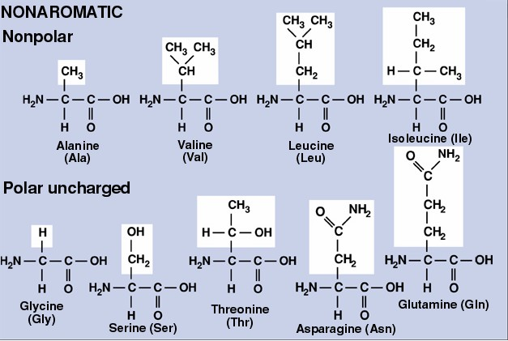
The variation in R groups gives amino acids different properties.

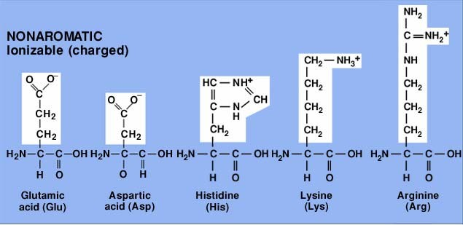
30

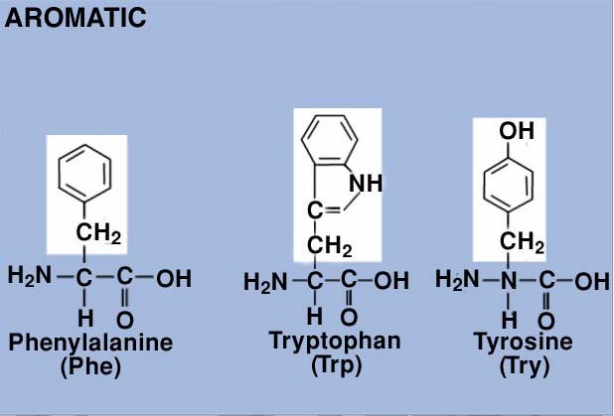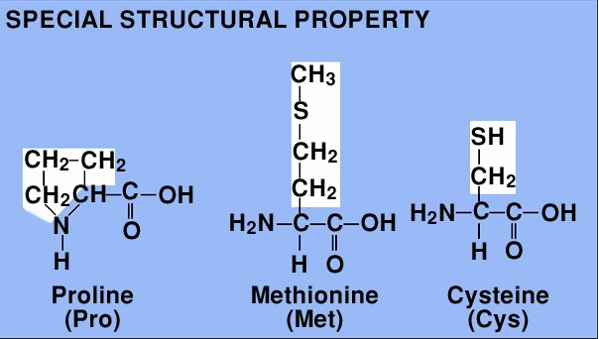

31

The diversity of protein function results from diversity of protein structure which is the result of variation in the sequence of amino acids.
Functional proteins can vary in length from about 50 amino acids to several thousand amino acids.
The variety of amino acid sequences that are possible for proteins is practically infinite. The class of all possible proteins 50 amino acids long consists of 2050 (or 1.1 x 1065) different combinations.
The diversity of amino acid sequence results in diversity of protein structure.
Protein structure can be classified at several different levels:
primary, secondary, tertiary, and quaternary.
32

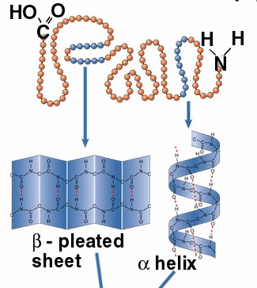
Primary (1°) structure - the amino acid sequence.
Met - Gly - His - Trp - Lys - ...

Secondary (2°) structure - the regular coiling and bending of the polypeptide that results from hydrogen bonding of amino and carboxyl groups in different amino acids.
This forms 2 characteristic structures - the α helix and the
β-pleated sheet.
33

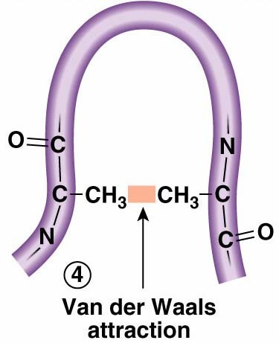
R groups of different amino acids can interact in a variety of ways to produce more complex structure.

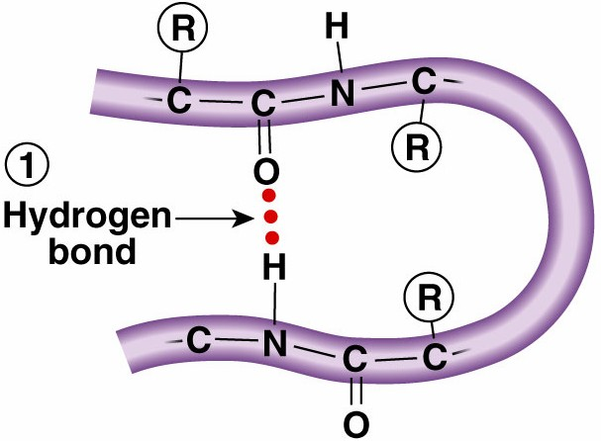
Hydrogen bonds are weak interactions between polar R groups

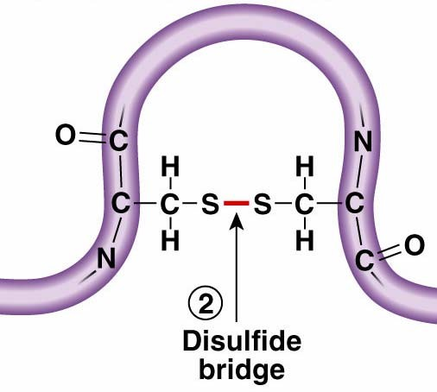
Some R groups form covalent bonds or ionic bonds.
Nonpolar R groups can have a weak attractive interaction.
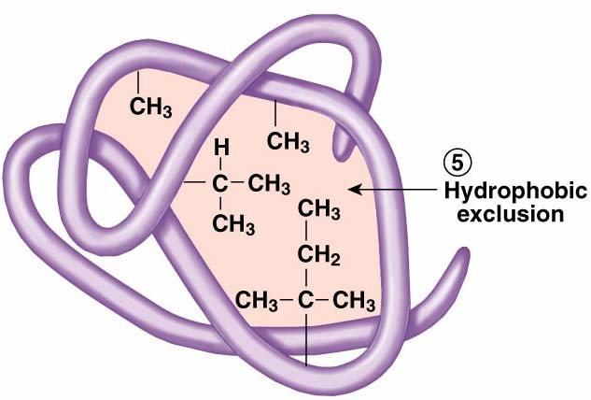
Because nonpolar R groups are hydrophobic they are found in

the interior of proteins. 34

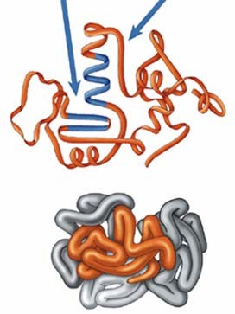
Tertiary (3°) structure - the bending and folding of the polypeptide in 3-D space due to the interactions of the R groups distant amino acids.
Interactions include:
hydrogen bonding, ionic bonding, covalent bonds, hydrophobic interactions, hydrophilic interactions
Quaternary (4°) structure - the interaction of different polypeptides

4° structure is the result of the same interactions as above. Not all
proteins have 4° structure. 35

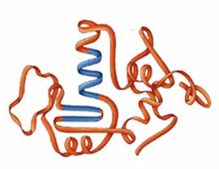Motifs and Domains - other components of structure within a protein
Motifs - super secondary structure - channels and grooves formed by associations of pleats and helices.

Domains - regions of local tertiary structure along the length of a protein that have different functions.

36

Protein structural diversity is responsible for the functional diversity of proteins. Protein shape causes protein function.
Small changes in shape can influence function.
Proteins are sensitive to environmental changes. Change in pH, temperature, ion concentration can all cause a change in the shape of the protein and influence its functional properties.
High temperatures result in weakening of H-bonds. Proteins tend to (unfold) at high temperature. Low temperatures strengthen H-bonds. Proteins become rigid at low temperature.

37

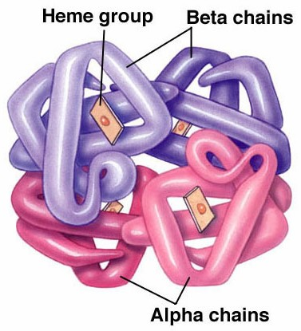
Hemoglobin (Hb) is a protein that carries oxygen in blood.
Hb has quaternary structure (it has 2 α chains and 2 β chains) and has an association with an iron containing molecule called Heme.
Hb is sensitive to change in pH. It carries oxygen well at high pH and does not at low pH.

Actively metabolizing tissues lower the pH of blood as it passes through them. At the lungs the pH increases as CO2 leaves the bloodstream. Hb picks up oxygen at the lungs and dumps it at actively metabolizing tissues.

38

Nucleic acids - nucleic acids are the repositories and carriers of information. All the information needed to make living things work is contained in nucleic acids. Nucleic acids also transmit the information needed to make living things work.

Nucleic acids are the basis of protein diversity and biological diversity. The information contained in the DNA makes organisms what they are.

Two types of nucleic acids, DNA - deoxyribonucleic acid RNA - ribonucleic acid

Both are polymers of nucleotides.

39

DNA is the . It contains the information that makes living things what they are. It is what is passed from parent to child through sperm or egg. It is what is contained in every cell in the body and dictates the function of that cell.
The information in DNA is expressed through the production proteins. The difference between any two living things is the result of differences in the proteins they synthesize and the DNA that contains the information for synthesizing them.
RNA mediates the expression of this information. RNA is responsible for protein synthesis.
In cells, DNA is contained in the nucleus, and is a major component of chromosomes. RNA is synthesized in nucleus but then moves out of the nucleus, into the cytoplasm of the cell, where it is used for and directs protein synthesis.

40

DNA and RNA are both polymers of nucleotides.

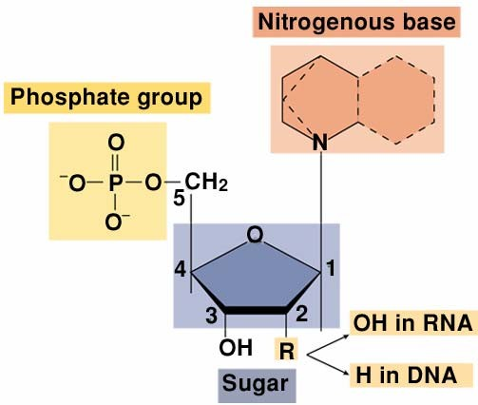
Nucleotides all have a central 5-carbon sugar, a nitrogenous base, and a phosphate group.

The sugar differs between DNA and RNA. RNA uses ribose. DNA uses deoxyribose. The two sugars differ in the functional group at their #2 carbon.

41

The nitrogenous bases found in DNA are Adenine, Thymine, Guanine and Cytosine. (A,T,G,C)
The nitrogenous bases found in RNA are Adenine, Uracil, Guanine, and Cytosine. (A,U,G,C)

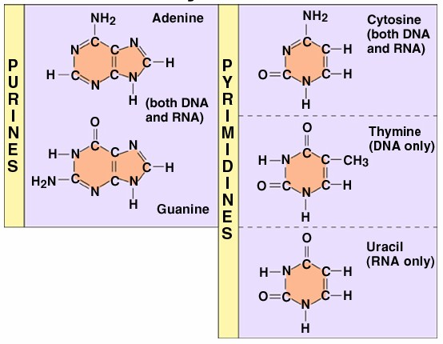
42

The linkage between nucleotides is called a phosphodiester bond.

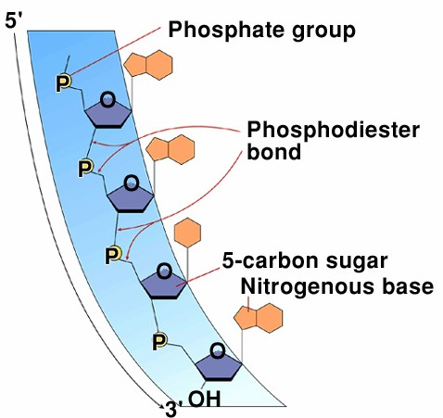
The sugars are oriented from their #5 carbon to their #3 carbon. The entire polymer has a 5’ → 3’ orientation.
The bases extend from the side of the polymer.
Both DNA and RNA are synthesized by adding new nucleotides to the 3’ end of the chain.

Nucleic acids have a .
43

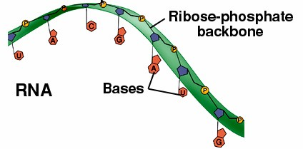
RNA is a single stranded polymer of nucleotides.

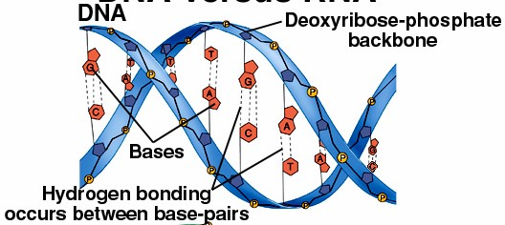
DNA is a double stranded molecule. The two strands wrap around each other, each as a helix. DNA is a .

44

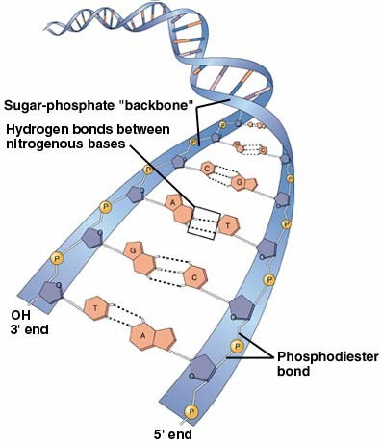
The two strands of DNA run in opposite directions. They are .

The two strands are held together by H-bonds between the nitrogenous bases in opposite strands.
A in one strand is opposite T in the other.
G in one strand is opposite C in the other.

45

Other uses for nucleotides
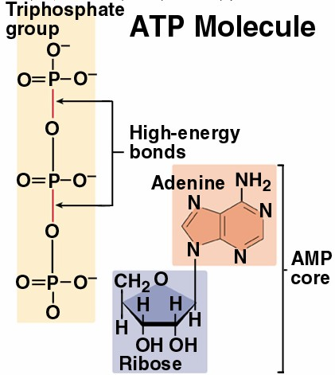
Nucleotides are also used in important energy transfer reactions.

ATP (Adenosine TriPhosphate) is the .
The bonds between the phosphate groups are high-energy bonds.
Energy is captured in the synthesis of phosphate bonds of ATP and released in the breakage of those bonds.

46

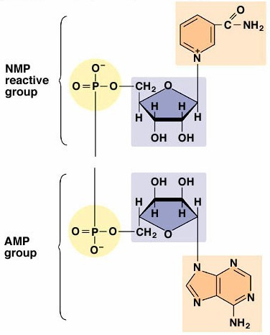NAD (Nicotinamide Adenine Dinucleotide) is composed of two nucleotides.
O
NAD is used in many oxidation-reduction reactions to accept or donate high- energy electrons

47

Reference: https://www.nicholls.edu/biol-ds/biol155/Lectures/Biological%20Molecules.pdf

